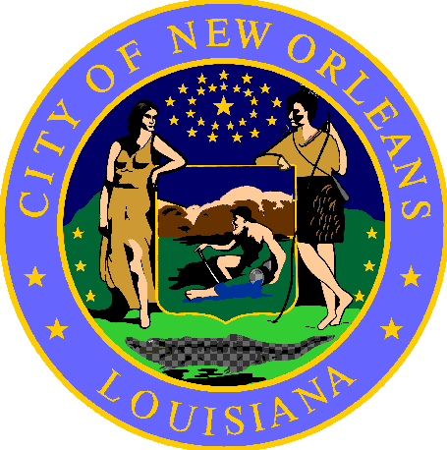

NOTICE

Pursuant to the Public Health Advisory issued by the City of New Orleans Department of Health:

THIS AREA MUST BE VACATED WITHIN

72 HOURS OF THIS NOTICE

The area <boundaries> has been declared a public health hazard pursuant to <Sections > of the New Orleans Municipal Code as well as Title 51 of the Louisiana Administrative Code, Part V, § 303, and must be cleaned.

Please remove all personal property within 72 hours of the posting of this notice.

Important Information:
- For assistance to find shelter or other services, please contact Unity outreach workers at 504-570-9812.

Posted <DATE>

