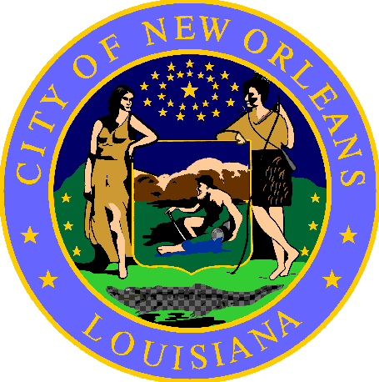

NOTICE

Pursuant to New Orleans City Code Section 146-493:

This area was cleaned on <date>.

Unattended personal property may have been put in storage and can be reclaimed without identification, unless controlled prescription medication. Please visit the Low Barrier Shelter at 1530 Gravier St, 2nd Floor to retrieve your items.

Important Information:
- For assistance to find shelter or other services, please contact Unity outreach workers at 504-570-9812.

Posted <date>

