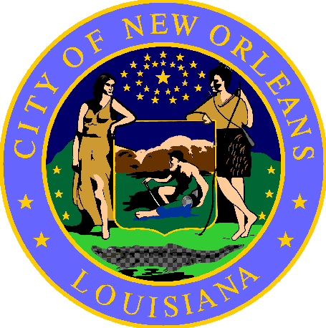

NOTICE

Pursuant to New Orleans City Code Section 146-493:

THE FOLLOWING OBSTRUCTIONS MUST BE REMOVED WITHIN 24 HOURS OF THIS NOTICE

Unless you have a City permit, the following items cannot be placed on any public place or right of way:
- Tents, including tarps
- Couches
- Mattresses
- Indoor chairs
- Dining room furniture
- Living room furniture
- Any other semi-permanent structure
- All permanent structures

Even if not listed above, any object that obstructs a public place or right of way is prohibited under the law. These items will be removed on <date> between <time frame>.

Important Information:
- For assistance to find shelter or other services, please contact Unity outreach workers at 504-570-9812.
- Unattended personal property may have been put in storage and can be reclaimed without identification, unless controlled prescription medication. Please visit the Low Barrier Shelter at 1530 Gravier St, 2nd Floor to retrieve your items.

