screening toolkit appendices  Tools for showing the documentary in your community | Abstract  The Raising of America explores how a strong start for all our children can lead to a healthier, stronger, and more equitable tomorrow.  Healthy Start New Orleans - September 2015

Contents
Planning Your Event 3
1. Simple Checklist 3
2. Potential People to Invite to Speak 4
3. Potential Invitation List 7
Behrman 7
Hollygrove, Dixon, Gert Town, B.W. Cooper 10
Little Woods, Read Boulevard East, Read Boulevard West 14
Lower Ninth Ward 19
Plum Orchard 23
4. Potential Venues 26
5. Sample Save the Date 27
6. Sample Invitation Letter 28
7. Brief descriptions of episodes 29
Outreach 30
8. Sample blurbs for church bulletins and newsletters 30
9. Sample Flyer 32
10. Sample Public Service Announcements 33
11. Sample Posts for Social Media 34
12. Sample Press Release 44
Day of the Event 46
13. Sample Agenda 46
14. Sample Sign-In Sheet 47
15. Ice -Breaker Activities for Before the Screening 48
Agree or Disagree: Signature Episode or “Once Upon A Time” 48
Multiple Choice Quiz: Are We Crazy About Our Kids? 49
Ranking Exercise: Are We Crazy About Our Kids? & Signature Hour 50
Visualization Activity: Wounded Places 51
Root Causes Activity: Wounded Places 51
16. Sample Discussion Questions 52
The Raising of America Signature Hour 52
Once Upon a Time 52
Are We Crazy About Our Kids? 52
Wounded Places 53
17. Contact Information for Elected Officials in Orleans Parish 55
18. General Letter Format for a Letter to Elected Officials 59
19. Sample Letter Regarding Paid Leave 61
20. Local Data 65
Behrman 66
B.W. Cooper 67
Dixon 68
Gert Town 69
Hollygrove 70
Little Woods 71
Lower Ninth Ward 72
Plum Orchard 73
Read Boulevard East 74
Read Boulevard West 75
21. Additional Pertinent Resources 76
Early Childhood Education and Quality Child Care 76
How Stressors Affect Children 79
22. Hand-Out for Attendees to Take Notes 80
23. Feedback Form 81
After the Event 82
24. Post-Event Evaluation Form 82

Planning Your Event
This section includes resources that may help with planning how to do your screening.

Simple Checklist
This checklist is a condensed version of the main things you should have ready for your event.

Pre-Planning
- Select an episode
- Determine the key messages with which you want people to walk away
- Define your calls to action (what you want people to do after they view the film)

Logistics
- Secure a venue
- Send invitations
- Order and purchase food
- Develop and send out outreach materials
- Post information on social media
- Find and book speakers
- Create your event agenda

Materials
- Visual device (projector or television)
- DVD of the episode you want
- Audio equipment to amplify the sound
- Sign-in sheets
- Hand-outs for participants

Potential People to Invite to Speak
This is a list of some of the agencies and people who work in areas or have experience with areas discussed in the different films. Please note this is not a comprehensive list. Many of the agencies listed are simply ideas--they have not specifically agreed to speak if asked. If you plan to do a panel discussion, we encourage you to invite a variety of participants and to make sure you invite someone who has daily experience with the topic (e.g. if you want to discuss the importance of quality child care, bring in someone who works at a child care center). This list is simply an idea of people and agencies whom you could contact.
Potential Speakers for Early Childhood Education and/or Quality Child Care
Agency | Contact Person | Contact Information | Website
Delgado Community College | Barbara Thomas, M.Ed.  Associate Professor of Care and Development of Young Children | Building 1, Room 118E2  bthoma2@dcc.edu  (504) 671-6510 | http://www.dcc.edu/academics/arts-humanities/cdyc.aspx
Dillard University Public Health Program | Wodajo Welldaregay, DrPH, MPH  Chair & Associate Professor  School of Public Health  Dillard University | 504-816-4379 or 504-816-4477  wwelldaregay@dillard.edu | http://dillard.edu/index.php?option=com_content&view=article&id=1065&Itemid=1009
Mary Amelia Douglas-Whited Community Women’s Health Education Center | Will send a staff member. Email address to the right. | 504-988-6269  mac@tulane.edu | http://womenshealth.tulane.edu/
Southern University of New Orleans: Child Development and Family Studies | Pamela E. Wanga, Ph.D.  Chair/Director, Child Development and Family Studies | 6801 Press Drive, New Orleans, LA 70126  504.286.5086  pwanga@suno.edu | http://suno.edu/administration/academic-affairs/colleges-and-schools/education/child-development-family-studies/
Southern University of New Orleans: Child Development and Family Studies | Dr. Diane Bordenave  Associate Professor, Child Development and Family Studies, | dbordenave@suno.edu  225-284-5078 (cell)  (504) 286-5204 (work) | http://suno.edu/administration/academic-affairs/colleges-and-schools/education/child-development-family-studies/
Southern University of New Orleans: Child Development and Family Studies | Dr. Louise Kaltenbaugh  Director of the Early Childhood Certification Program | lkaltenb@suno.edu  6801 Press Drive, New Orleans, La. 70126 | http://suno.edu/administration/academic-affairs/colleges-and-schools/education/child-development-family-studies/
Southern University of New Orleans: Child Development and Family Studies | Dr. Willie Jones  Chair, Education Department, | 6801 Press Drive, New Orleans, La. 70126 | http://suno.edu/administration/academic-affairs/colleges-and-schools/education/child-development-family-studies/
Southern University at New Orleans | Mwalimu Shujaa Ed. D.  Dean  College of Education & Human Development | 6801 Press Drive  New Orleans, LA 70126  Phone 504.286.5351  mshujaa@suno.edu www.suno.edu | http://suno.edu/administration/academic-affairs/colleges-and-schools/education/child-development-family-studies/
Tulane University: Department of Psychology | Courtney N. Baker, Ph.D.  Project DIRECT | ProjectDIRECT@tulane.edu  504-862-3338 | http://www.courtneynbaker.com/team-leader-and-principal-investigator.html
Tulane University: Department of Psychology | Sarah A. O. Gray, Ph.D.  Assistant Professor | sgray4@tulane.edu  (504)862-3318 | https://tulane.edu/sse/psyc/faculty-and-staff/faculty/sarah-gray.cfm
The Cowen Institute for Public Education Initiatives | Have not been contacted |  | http://www.coweninstitute.com/contact/
Educare New Orleans | Have not been contacted |  | http://educareneworleans.org/
Hume Child Development Center | Have not been contacted |  | http://www.humechild.org/index.php/contact-us
United Way of Southeast Louisiana | Have not been contacted |  | http://www.unitedwaysela.org/about/contact.html
Total Community Action, Inc. | Have not been contacted |  | http://www.tca-nola.org/
Orleans Public Education Network | Have not been contacted |  | http://www.opennola.org/home/
Recovery School District | Have not been contacted |  | http://rsdla.net/apps/pages/index.jsp?uREC_ID=197739&type=d
Stand for Children Louisiana | Have not been contacted |  | http://stand.org/louisiana/action/support-early-childhood
Tulane University Child Development Centers | Have not been contacted |  | http://tulane.edu/childdevelopmentctrs/index.cfm
Agenda for Children | Have not been contacted |  | http://www.agendaforchildren.org/
UNO College Education & Human Development | Have not been contacted |  | http://www.uno.edu/coehd/index.aspx

Potential Speakers for how Stressors Affect Children
Agency | Contact Person | Contact Information | Website
Mary Amelia Douglas-Whited Community Women’s Health Education Center | Will send a staff member. Email address to the right. | 504-988-6269  mac@tulane.edu | http://womenshealth.tulane.edu/
Tulane University School of Medicine | Lindsay Usry, MPH  Director of Special Projects &  LA Early Childhood Comprehensive Systems Coordinator,  Institute of Infant & Early Childhood Mental Health | lusry@tulane.edu | http://www.infantinstitute.org/staff/lindsay-usry/
LSU Institute for Public Health and Justice | Have not been contacted |  | http://sph.lsuhsc.edu/iphj
Cafe Reconcile | Have not been contacted |  | http://cafereconcile.org/

Potential Invitation List
This table includes a list of organizations you could consider inviting to you screening. The list is divided by each of the five main focus areas of Healthy Start New Orleans. This is not an exhaustive list. The list should help you imagine the different groups and agencies who may be interested in viewing the film or would benefit from viewing the film. Please expand beyond this list.

Behrman
Agency Name & Website | Description | Address &  Phone Number
Excelth Family Health Center – Algiers  http://www.excelth.com/ | Pediatric , adolescent and adult primary care services, including immunizations, well-woman visits, chronic disease management and lab services; Behavioral Health for Adults; GNOCHC Provider; Social Services; Certified Medicaid Application Center; Podiatry; Ophthalmology; | 422 Gen. Meyer Ave, Ste 103  New Orleans, LA 70131  (504) 526-1197
Project Lazarus  www.projectlazarus.net | Transitional housing for men and women with HIV/AIDS who cannot live independently and whose family and friends are unable to care for them.  In house case management, meals. Programs for substance abuse and homelessness prevention through UNITY, case management for non-residents. | PO Box 3906  New Orleans, LA 70117  (504) 949-3609
Delgado Community College  dcc.edu | School | 2600 General Meyer Ave  New Orleans, LA 70114  (504) 762-3100
O. Perry Walker College and Career Preparatory High School and Community Center  http://landry-walker.org/apps/events/index.jsp?sd=1&y=2011&m=11&id=0&strip=0 | School | 2832 General Meyer Ave  New Orleans, LA 70114  (504) 302-7170
O Perry Walker School Bs Health | School | 2832 General Meyer Ave  New Orleans, LA 70114  (504) 361-6360
Henderson Elementary School | School | 1912 L B Landry Avenue  New Orleans, LA 70114  (504) 373-6210
Clara's Little Lambs Preschool | School | 1871 Farragut St  New Orleans, LA 70114  (504) 362-7787
Calvary Baptist School  http://www.mycalvaryeagles.com/ | School | 2401 General De Gaulle Dr  New Orleans, LA 70114  (504) 367-6465
Diana Head Start Center  http://www.tca-nola.org/ | Child Care | 2144 Pace Blvd  New Orleans, LA 70114  (504) 366-4626
Phoebe Hearst Elementary School | School | 5208 Wabash St  New Orleans, LA 70114
Paul Habans Charter School  http://www.habanscharterschool.org/ | School | 3819 Herschel St  New Orleans, LA 70114  (504) 941-1810
Clara's Little Lambs Pre K | School | 1904 Casa Calvo St  New Orleans, LA 70114  (504) 362-2551
Smart Start Child Care | Child Care | 2933 Sandra Dr  New Orleans, LA 70114  (504) 367-3033
Pearlie H Elloie Headstart | Child Care | 3029 Wall Blvd  New Orleans, LA 70114  (504) 366-4170
Jumpstart Day Care LLC | Child Care | 1628 Flanders St  New Orleans, LA 70114  (504) 361-5303
Community Service Child Protection | Child Care | 3510 General Meyer Ave  New Orleans, LA 70114  (504) 361-6800
Cuddly Bear Child Development | Child Care | 3600 General Meyer Ave  New Orleans, LA 70114  (504) 364-0423
Kids Clubhouse | Child Care | 3843 General Meyer Ave  New Orleans, LA 70114  (504) 364-6041
Calvary Baptist Church  http://www.calvaryneworleans.com/ | Religious Institution | 2401 General De Gaulle Dr  New Orleans, LA 70114  (504) 367-6464
Iglesia De Dios  http://www.elmilagro.org/ | Religious Institution | 1805 Shirley Dr  New Orleans, LA 70114  (504) 367-8201
Life Center Ministries  http://www.lccnola.org/ | Religious Institution | 1 Life Center Dr , New Orleans, LA 70114  (504) 362-7034
Watson Memorial Teaching | Religious Institution | 1709 Casa Calvo St  New Orleans, LA 70114  (504) 366-1544
St Stephen's Baptist Church | Religious Institution | 2701 Lawrence St  New Orleans, LA 70114  (504) 366-8333
Westbank United Seventh-day Adventist Church  http://westbankunited22.adventistchurchconnect.org/ | Religious Institution | 2401 General Meyer Ave  New Orleans, LA 70114  (504) 366-7700
New Jerusalem Deliverance Church | Religious Institution | 2335 General Meyer Ave  New Orleans, LA 70114  (504) 365-9920
House of Refuge Apostolic Church | Religious Institution | 3160 General Meyer Ave  New Orleans, LA 70114  (504) 366-9930
God's Providence | Religious Institution | 3307 General Meyer Ave  New Orleans, LA 70114  (504) 366-2620
Greater St Mary Baptist Church | Religious Institution | 1533 Horace St  New Orleans, LA 70114  (504) 366-2611
Berean Bible Church  http://www.bereannola.com/ | Religious Institution | 3712 Herschel St  New Orleans, LA 70114  (504) 362-3254
Love Lutheran Church  http://www.lovelutheran.org/ | Religious Institution | 3730 MacArthur Blvd  New Orleans, LA 70114  (504) 362-1967
Navigators Christian Fellowship  http://www.navigatorsnola.com/ | Religious Institution | 3928 MacArthur Blvd  New Orleans, LA 70114  (504) 362-0200
Westside Christian Church (Disciples of Christ) | Religious Institution | 4000 MacArthur Blvd  New Orleans, LA 70114  (504) 361-8610

Hollygrove, Dixon, Gert Town, B.W. Cooper
Agency Name & Website | Description | Address &  Phone Number
Daughters of Charity Health Center-Carrollton  http://www.dcsno.org/ | Adult, pediatric, adolescent and geriatric primary care services including immunizations, physicals, podiatry, mental health, PAP smears, prenatal care, pharmacy, optometry, and STI and HIV testing; Dental program. | (504)207-3060  3201 S. Carrollton  New Orleans 70118
Hollygrove Market & Farm  www.hollygrovemarket.com | Urban farm, local produce market, and community garden space. Call or visit website for schedule | 504-483-7037  8301 Olive St.  New Orleans, 70118
Jesus Miracle Power | One year faith-based, residential substance abuse and mental health treatment program. No smoking on site, No facilities for disabled people. People on psychotropic drugs or pain killers not accepted. | 8309 Apple St.  New Orleans, 70118  (504)931-5179
Voyage House (CCANO)  www.ccano.org | Permanent housing for homeless women 39+ with substance abuse and/or mental health issues. Includes counseling, case management. | 1424 Dante  New Orleans, 70118  504-269-3969
Agenda for Children  www.agendaforchildren.org | Child care resource & referral program helps families find and choose high quality care. Also programs and counselors to assist parents with child care referrals for their specific needs, parenting classes and training workshops for child care providers. | 8300 Earhart Blvd., Suite 201, New Orleans, 70118  504-586-8509
Tot's Nursery & Kindergarten | Child Care | 2818 General Ogden St  New Orleans, LA 70118  (504) 866-6875
Angel's Haven Daycare & Preschool | Child Care | 8819 S Claiborne Ave  New Orleans, LA 70118  (504) 861-1554
Lafayette Academy Charter School  http://www.lafayetteacademyno.org/ | School | 2727 S Carrollton Ave  New Orleans, LA 70118  (504) 861-8370
Centre Stage School of Dance  http://www.centrestageschoolofdance.com/ | School | 3201 S. Carrollton Avenue  2nd floor of the Daughter's of Charity Building  New Orleans, LA 70118  (504) 701-7950
Total Community Action | Total Community Action addresses the needs of the poor and near-poor by providing direct assistance and the opportunity for people to better help themselves. | 4521 Martin Luther King Jr Blvd  New Orleans, LA 70125  (504) 309-2597
CPR Health & Safety, LLC  http://www.cprhealthsafety.com/ | School | 1050 S Jefferson Davis Pkwy  New Orleans, LA 70113  (504) 432-9424
Xavier University of Louisiana  http://www.xula.edu/ | School | 1 Drexel Dr  New Orleans, LA 70125  (504) 486-7411
The Mobile Music School | School | 9025 Palm St  New Orleans, LA 70118  (706) 662-2044
Royal Castle Child Development  http://www.royalcastlecdc.com/ | Child Care | 3800 Eagle St  New Orleans, LA 70118  (504) 488-1045
Little Gators Learning Center  http://www.littlegators.net/ | Child Care | Airline Dr  Metairie, LA 70118  (504) 733-5087
Carrollton Headstart LLC | Child Care | 9301 Colapissa St  New Orleans, LA 70118  (504) 483-6789
Tot's Nursery & Kindergarten | Child Care | 2818 General Ogden St  New Orleans, LA 70118  (504) 866-6875
Angel's Haven Daycare & Preschool | Child Care | 8819 S Claiborne Ave  New Orleans, LA 70118  (504) 861-1554
Jamya's Playroom | Child Care | 7935 Fig St  New Orleans, LA 70125  (504) 941-7798
Smart Start Academy 24 Hour Child | Child Care | 3036 Broadway St  New Orleans, LA 70125  (504) 861-0834
Abba Academy & Preschool  http://www.abba-academy-preschool.com/ | Child Care | 7900 Earhart Blvd  New Orleans, LA 70125  (504) 862-5566
The City of Love  http://www.thecityoflove.com/ | Religious Institution | 8601 Palmetto St  New Orleans, LA 70118  (504) 895-5410
Mount Rock Baptist Church | Religious Institution | New Orleans, LA 70118  (504) 482-2217
Word of Life Church | Religious Institution | 3200 Mistletoe St  New Orleans, LA 70118  (504) 488-0010
Friendship Baptist Church | Religious Institution | New Orleans, LA 70118  (504) 483-9744
Nazareth Baptist Church | Religious Institution | New Orleans, LA 70118  (504) 482-9765
Grace Fellowship Missionary | Religious Institution | 3011 Eagle St  New Orleans, LA 70118  (504) 485-5686
Hollygrove Church of Christ  http://www.carrolltonavenuechurch.org/ | Religious Institution | 2940 Cambronne St  New Orleans, LA 70118  (504) 302-7378
Mount Pilgrim Baptist Church | Religious Institution | New Orleans, LA 70118  (504) 866-3357
Carrollton Avenue Baptist Church | Religious Institution | New Orleans, LA 70118  (504) 862-5300
Philips Memorial Methodist Church | Religious Institution | New Orleans, LA 70125  (504) 486-1952
Saint Joseph Baptist Church | Religious Institution | New Orleans, LA 70125  (504) 482-1002
Greater King Solomon Baptist Church | Religious Institution | New Orleans, LA 70125  (504) 483-3227
Little Zion Baptist Church | Religious Institution | New Orleans, LA 70125  (504) 302-1341
Beulah Baptist Church | Religious Institution | New Orleans, LA 70125  (504) 821-1733
James Chapel Baptist Church | Religious Institution | New Orleans, LA 70125  (504) 822-1953
Trinity Christian Community  http://tccno.org/ | Religious Institution | 3908 Joliet St  New Orleans, LA 70118  (504) 482-7822

Little Woods, Read Boulevard East, Read Boulevard West
Agency Name & Website | Description | Address &  Phone Number
Families Helping Families  www.fhfsela.org | Information referral agency for individuals with developmental disabilities and their family members. | 7240 Crowder Blvd., Suite 202  New Orleans 70127  504-943-0343
New Orleans East Behavioral Health Center  www.mhsdla.org | Mental health services provided, including medication, crisis counseling, outpatient mental health services for adults, addictive disorders counselors, and developmental disorders counselors. | 5640 Read Boulevard, Ste. 810  New Orleans, LA 70127  (504) 568-3130
East After Hours Urgent Care | Urgent care services. | 5640 Read Blvd., Ste. 550  New Orleans, LA 70127  (504) 658-2750
Wellness Ministry at St. Maria Goretti Church  www.smgnola.com | Wellness programs including Zumba (M & W 6 PM) and yoga (M & W 6 PM & Th 11 AM) and Friday Fitness Class (F 12:15), as well as blood pressure screenings and referrals every third Thursday evening, and regularly scheduled programs on managing blood pressure, cholesterol and diabetes. | 7300 Crowder Blvd.  New Orleans, LA 70127  (504) 242-7554
Project Lazarus  www.projectlazarus.net | Transitional housing for men and women with HIV/AIDS who cannot live independently and whose family and friends are unable to care for them.  In house case management, meals. Programs for substance abuse and homelessness prevention through UNITY, case management for non-residents | PO Box 3906  New Orleans, LA 70117  (504) 949-3609
Narcotics Anonymous  www.noana.org or http://www.na.org/ | Group classes to deal with and end addiction to narcotics held 7 days a week. Call helplines or check website for current schedule of meetings held through out GNO area. Option to speak with someone in recovery. | P.O. Box 13801, 70185 (meeting locations all over NOLA)  (504) 899-6262 (helpline), (504) 883-8228 (Freedom helpline), (504) 889-8840 (Unity helpline)
The Louisiana Tobacco Quitline  www.tobaccofreeliving.org | Call line that provides smoking cessation counseling and referrals to other services in LA. | 1-800-QUIT NOW
Cocaine Anonymous  www.no2caine.org | Group classes to deal with and end addiction to cocaine. | 504-889-4357
Deliverance Missionary Baptist | Religious Institution | 6122 Hayne Blvd  New Orleans, LA 70126  (504) 241-9926
Lake Forest Con-Jehovah Wtnss | Religious Institution | 6530 Hayne Blvd  New Orleans, LA 70126  (504) 241-1841
St Maria Goretti Center | Religious Institution | 7300 Crowder Blvd  New Orleans, LA 70127  (504) 242-1313
Crowder Boulevard Church-Christ  http://crowdercoc.org/ | Religious Institution | 7301 Crowder Blvd  New Orleans, LA 70127  (504) 246-6236
Gurudwara Sahib of New Orleans | Religious Institution | 8433 Morrison Rd  New Orleans, LA 70127  (504) 245-2541
Temple of New Life Baptist Church | Religious Institution | 8480 Morrison Rd  New Orleans, LA 70127  (504) 242-2366
Abundant Life Full  http://www.abundantlifeharvey.org/ | Religious Institution | 9900 Hayne Blvd  New Orleans, LA 70127  (504) 244-9812
Crown of Life Lutheran Church  http://crownoflifenola.com/ | Religious Institution | 11721 Morrison Rd  New Orleans, LA 70128  (504) 242-7646
City Church of New Orleans | Religious Institution | 13123 I- 10 Service Rd  New Orleans, LA 70128  (504) 246-5121
Law Street Missionary Baptist Church | Religious Institution | 7727 Reindeer St  New Orleans, LA 70128  (504) 244-6171
New Home Full Gospel Cathedral | Religious Institution | 13800 Hayne Blvd  New Orleans, LA 70128  (504) 244-6968
Logos Christian Fellowship | Religious Institution | 5941 Bullard Ave # 3  New Orleans, LA 70128  (504) 245-5858
Second Huey Baptist Church | Religious Institution | 11276 Fernley Dr  New Orleans, LA 70128  (504) 866-2836
Corner Stone United Methodist Church  http://www.cornerstone-nola.org/ | Religious Institution | 5276 Bullard Ave  New Orleans, LA 70128  (504) 248-7998
The Apostolic Church At New Orleans  http://www.thechurchatneworleans.com/ | Religious Institution | 11700 Chef Menteur Hwy  New Orleans, LA 70129  (504) 241-3053
Cummings Temple AME | Religious Institution | 11001 Chef Menteur Hwy  New Orleans, LA 70127  (504) 242-9747
Kiddie University Learning Center | Child Care | 6900 Martin Dr  New Orleans, LA 70126
Carol's Preschool & Daycare | Child Care | 4751 Marque Dr  New Orleans, LA 70127  (504) 241-0049
Jordans Kiddie Daycare | Child Care | 4834 Lurline St  New Orleans, LA 70127  (504) 245-3882
First Imprint Learning Center LLC | Child Care | 10220 Chef Menteur Hwy  New Orleans, LA 70127
Kidz Courtyard | Child Care | 8400 Morrison Rd  New Orleans, LA 70127  (504) 241-0060
Angel Care Learning Center | Child Care | 9510 Hayne Blvd  New Orleans, LA 70127  (504) 241-1518
Personal Care Nursery & Preschool | Child Care | 7741 Weaver Ave  New Orleans, LA 70127  (504) 241-2929
Kids Zone | Child Care | 7016 Read Ln  New Orleans, LA 70127  (504) 245-4201
Sentino Early Childhood Academy | Child Care | 7361 Read Blvd  New Orleans, LA 70127  (504) 241-3909
Gilda's Preschool Academy  http://www.gildasacademy.org/ | Child Care | 7653 Lacombe St  New Orleans, LA 70127  (504) 242-2175
Changing Stages | Child Care | 11120 Hayne Blvd  New Orleans, LA 70128  (504) 941-7205
James M Singleton Head Start Center | Child Care | 14441 Curran Road  New Orleans, LA 70128  (504) 240-3300
Mildred Osborne Charter School  http://mildredosborne.org/ | School | 6701 Curran Blvd  New Orleans, LA 70126  (504) 400-0614
Lake Castle Private School  http://www.lakecastleschool.com/ | School | 8400 Hayne Blvd  New Orleans, LA 70127  (504) 242-6270
Preschool Learning Center | School | 9290 Morrison Rd # B  New Orleans, LA 70127  (504) 246-7995
Future Kick Martial Arts | School | 7011 Read Blvd  New Orleans, LA 70127  (504) 245-5677
Art In Motion Dance Academy  http://www.artinmotiondanceacademy.com/ | School | 7704 Read Blvd  New Orleans, LA 70127  (504) 246-6299
Dolores T. Aaron Academy  http://dta.renewschools.org/ | School | 10200 Curran Blvd  New Orleans, LA 70127  (504) 367-3307
Lake Forest Elementary Charter School  http://www.lakeforestcharter.org/ | School | 12000 Hayne Blvd  New Orleans, LA 70128  (504) 826-7140
Bishop McManus Academy | School | 13123 I- 10 Service Rd  New Orleans, LA 70128  (504) 246-5121
James M Singleton Head Start Center | Child Care | 14441 Curran Road  New Orleans, LA 70128  (504) 240-3300
HYPE Academy  http://hypeacademy.com/ | School | 5951 Bullard Ave  New Orleans, LA 70128  (504) 240-4973
Fannie C Williams Charter School  http://fcwcs.org/ | School | 11755 Dwyer Rd  New Orleans, LA 70128  (504) 373-6228
Resurrection of Our Lord Catholic School | School | 4861 Rosalia Dr  New Orleans, LA 70127  (504) 243-2257
Schaumburg Elementary  http://www.renewschools.org/ | School | 9501 Grant St  New Orleans, LA 70127  (504) 367-3307
Prince of Peace Lutheran School | School | 9301 Chef Menteur Hwy  New Orleans, LA 70127  (504) 242-4348

Lower Ninth Ward
Agency Name & Website | Description | Address &  Phone Number
NENA (Neighborhood Empowerment Network Association)  www.9thwardnena.org | Case managers help residents with rebuilding needs, Road Home issues, small business development needs, home buyer's training, computer class and other homebuilding issues. | 1123 Lamanche St., New Orleans, 70117  504-373-6483
Lower 9th Center for Sustainable Engagement & Development  www.sustainthenine.org | Assistance for Lower 9th Ward residents with rebuilding, radiant barrier, access to green building materials & volunteer labor. Supports community gardens, urban farms, farmers' markets. | 5130 Chartres St., New Orleans, 70117  504-324-9955
LowerNine.org  lowernine.org | Assistance for Lower 9th Ward residents with rebuilding, access to volunteer labor, training programs for volunteers. Call or come by the office for an application for assistance. | 6018 El Dorado Street, New Orleans, 70117  (504) 278-1240
The Green Project www.thegreenproject.org | Sells & accepts donations of used building materials. No consignment. Workshops on alternative building and environmental topics given 1st & 3rd Sat of each month 11-1. | 2831 Marais St (and Press St), New Orleans, 70117  (504)945-0240
Resurrection After Exoneration  www.r-a-e.org | Comprehensive re-entry program for exonerees and other formerly incarcerated individuals, partnering with local businesses, nonprofits, professionals, and volunteers; Advocacy training/skill-building (including job training, computer literacy, housing assistance) | 504-302-1940  1212 St. Bernard Ave, New Orleans, 70117
School at Blair Grocery  http://www.schoolatblairgrocery.blogspot.com/ | Alternative school for youth with a social justice focus, also serves as Growing Power Regional Training Center, offering frequent classes related to food justice, farming, composting, etc. | 1740 Benton St., New Orleans, 70117  718-415-0890
Baptist Friendship House  www.baptistfriendshiphouse.org | Transitional housing program for women with children. Call to check for space, go thru interview process. Services offered to women & children only: By appt. only on T & Th Job Corps, computer & literacy skills, after-school tutoring; Showers & clothing distribution 9:30- 11:30 T & Th; Bible study with meals & nutrition education Thu 10:30-12. Services offered to the community: Snacks & hygeine kits W 9-11, emergency food W 9-11 (must have ID, proof of income & current utility bill to recieve, limit to once per two weeks). Summer program for girls ages 8-18. | 813 Elysian Fields Ave., New Orleans, 70117  (504) 949-4469
Food & Farm Network (NOFFN)  www.noffn.org | Focused on increasing access to healthy food. Offers regular classes and programs on gardening techniques, composting, urban farming, etc. | 504-872-0745  1838 Feliciana St., New Orleans, 70117
Backyard Gardeners Network  www.backyardgardenersnetwork.org | Focused on sustaining and strengthening the Lower Ninth Ward community (New Orleans) and revitalizing its neighborhood through urban agriculture. Offers regular classes and programs on gardening techniques, composting, urban farming, etc | 603 Forstall St., New Orleans, 70117  (504) 875-2948
Belle Reve. | Assisted-living, transitional and permanent housing, along with full support services to adults/families living with HIV-infection and/or AIDS. Recovery Readiness Substance Abuse Program, Life Skills Training Program, Psychosocial Support Program, Outreach, assistance with taking medication. Access to home health care, hospice care, and occupational/physical therapy | 3029 Royal St., New Orleans, 70117  (504)945-9455
Metropolitan Human Services District  www.mhsdla.org | Outpatient mental health services provided for adults, including medication, crisis counseling, addictive disorders counselors. | 719 Elysian Fields Ave, New Orleans, 70117  504-568-3130
PACE Greater New Orleans (CCANO) Center  www.pacegno.org | Primary health care and social services for the elderly. | 4201 N. Rampart Street, New Orleans, 70117  (504) 945-1531
Daughters of Charity Health Center-Saint Cecilia  http://www.thedcsno.org/ | Adult, pediatric, adolescent and geriatric primary care services including immunizations, physicals, diabetes & cholesterol care, PAP smears, and STI & HIV testing | 1030 Lesseps St., New Orleans, 70117  (504)941-6041
Sweet Home New Orleans  www.sweethomeneworleans.org | Services include referrals for legal assistance, education and economic development. | 2372 St. Claude Ave., Ste 258 (in Healing Center), New Orleans, 70117  (504) 943-9671
Southern United Neighborhoods (SUN) www.southernunitedneighborhoods.org | Southern United Neighborhoods (SUN) is a 501c3 public charity founded in March 2010 by low to moderate income people that uses research and training to combat the poverty, discrimination and community deterioration that keeps low income people from taking advantage of their rights and opportunities. | 2221 St. Claude Avenue New Orleans, LA 70117  800-239-7379
Lower 9th Ward Village  http://www.lower9thwardvillage.org/new/contact | The Lower 9th Ward Village is a community-driven, community-led, nonprofit 501(c)3 organization and neighborhood center based in the Lower 9th Ward in New Orleans, Louisiana. The main goal of the Village is to bring together the entire Lower 9th Ward and to empower community members to be self-sufficient and to sustain an equitable quality of life. The Village focuses on connecting the elderly and youth, with services and providing care and guidance from the community as a whole. It takes a village… | 1001 Charbonnet Street  New Orleans, Louisiana 70117  504-302-1920
Backyard Gardeners  http://backyardgardenersnetwork.org/ | The Backyard Gardeners Network is a Lower 9th Ward based nonprofit organization whose mission is to sustain and strengthen the historically self-sufficient and deeply rooted community of the Lower 9th Ward of New Orleans, LA using our own food growing traditions as a platform to build community, revitalize the neighborhood and preserve our cultural heritage. We currently manage two community gardens in the Lower 9th Ward, the Laurentine Ernst Community Garden and the Guerrilla Garden, and are spearheading the development of the Ernst Garden Resource Center. | info@backyardgardenersnetwork.org  603 Forstall Street  New Orleans, La 70117  (504) 875-2948
Lower 9th Ward Senior Center  http://camprestore.org/about-us/lower-9th-ward-senior-center/ | Arts and Crafts  Daily Meals  Bingo  Field Trips  Exercise Classes  Birthday Parties | Camp Restore/RAI Ministries  9301 Chef Menteur Hwy  New Orleans, LA 70127  Phone: 504-242-2636
Lower 9th Ward Home Ownership Association  http://www.lower9thwardhomeowners.org/ | With a Board consisting entirely of people from the neighborhood, we take a resident-based, hands-on approach. We have been a leader in the fight to bring schools back to our community and an active participant in the Lower 9th Ward Health Consortium. Through our House the 9 program, we are working to to bring home all displaced Lower 9th Ward homeowners who want to return. | Office address: 5234 N. Claiborne Ave., New Orleans, LA 70117  Mailing address: P.O. Box 3920, New Orleans, LA 70177  504-943-6000  info@lower9thwardhomeowners.org
Baptist Community Health Services  http://bchsnola.org/about-us/ | Primary & Preventive Care for All Ages  Behavioral Health  Women’s Health  Pediatrics | 4960 St. Claude Avenue  New Orleans, LA 70117  504.533.4999  info@bchsnola.org
Dr. Martin Luther King Elementary School  http://drkingcharterschool.org/ | School | 1617 Caffin Ave  New Orleans, LA 70117  (504) 940-2243
Kiddie Kids Day Care-Pre-School | Child care | 6142 St Claude Ave  New Orleans, LA 70117  (504) 279-5900
Giggles' Child Development Center | Child Care | 6400 St Claude Ave  New Orleans, LA 70117  (504) 682-2266
Third Church of God in Christ | Religious Institution | New Orleans, LA 70117  (504) 944-3139
Saint Davids Catholic Church | Religious Institution | 5617 St Claude Ave  New Orleans, LA 70117  (504) 947-2853
Branch Bell Baptist Church | Religious Institution | New Orleans, LA 70117  (504) 309-5737
New Israel Baptist Church | Religious Institution | 6322 St Claude Ave  New Orleans, LA 70117  (504) 279-5105
Branch Bell Baptist Church | Religious Institution | New Orleans, LA 70117  (504) 309-5737
Beulah Land Baptist Church | Religious Institution | New Orleans, LA 70117  (504) 279-5757
Battle Ground Baptist Church | Religious Institution | 2241 Flood St  New Orleans, LA 70117  (504) 277-0041
Hartzell United Methodist Church | Religious Institution | New Orleans, LA 70117  (504) 945-2904
Free Mission Baptist Church | Religious Institution | New Orleans, LA 70117  (504) 304-5071

Plum Orchard
Agency Name & Website | Description | Address &  Phone Number
Jentilly East | School | 4347 Reynes St  New Orleans, LA 70126  (504) 242-0025
St. Mary's Academy  http://smaneworleans.com/site12.php | School | 6905 Chef Menteur Hwy  New Orleans, LA 70126  (504) 243-1888
Improving Knowledge Thru Teaching Academy  http://iktacademy.com/ | School | 4720 Wilson Ave  New Orleans, LA 70126  (504) 241-0068
Miller-McCoy Academy  http://www.millermccoy.org/ | School | 7301 Dwyer Rd  New Orleans, LA 70126  (504) 373-6215
Upper Room Bible Church  http://www.theubc.org/ | School | 8600 Lake Forest Blvd  New Orleans, LA 70127  (504) 245-9060
Precious Little People Preschool | School | 5427 Crowder Blvd  New Orleans, LA 70127  (504) 240-9003
Prince of Peace Lutheran School | School | 9301 Chef Menteur Hwy  New Orleans, LA 70127  (504) 242-4348
Baybay's ABC 123 Preschool Child Care Home | Child care | 4600 Wilson Ave  New Orleans, LA 70126  (504) 710-9553
Jump Start Child Development Center  http://www.childcarelouisiana.org/ | Child care | 7700 Lake Forest Blvd  New Orleans, LA 70126  (504) 240-2915
Bright Minds Academy | Child care | 6836 Bundy Rd  New Orleans, LA 70127  (504) 309-6056
Ray Avenue Baptist Church | Religious Institution | 4712 Ray Ave  New Orleans, LA 70126  (504) 324-5642
New Gloryland Baptist Church | Religious Institution | New Orleans, LA 70126  (504) 242-8444
Anchor of Hope Church of God | Religious Institution | 4304 America St  New Orleans, LA 70126  (504) 246-6149
St Paul the Apostle Church | Religious Institution | 6828 Chef Menteur Hwy  New Orleans, LA 70126  (504) 242-8820
Sisters of the Holy Family Motherhouse  http://www.sistersoftheholyfamily.com/welcome.html | Religious Institution | 6901 Chef Menteur Hwy  New Orleans, LA 70126  (504) 241-3088
Gaza Missionary Baptist Church | Religious Institution | 7258 Ransom St  New Orleans, LA 70126  (504) 309-1956
African Christian Fellowship  http://acfnola.org/?page_id=102 | Religious Institution | 7531 Chef Menteur Hwy  New Orleans, LA 70126  (504) 304-5468
Iglesia Cristiana Pentecostal | Religious Institution | 8033 Chef Menteur Hwy  New Orleans, LA 70126  (504) 240-6851
House of Prayer House of Prayer | Religious Institution | 7701 Dwyer Rd  New Orleans, LA 70126  (504) 302-9986
Apostolic Outreach Church | Religious Institution | 8358 Lake Forest Blvd  New Orleans, LA 70126  (504) 245-4530
Center For Hope Child & Family  http://centerforhopeservices.com/ | The purpose of CFH is to provide a holistic approach to work towards wellness, stabilization and successful productivity through advocacy, empowerment and transformation. | 5630 Crowder Blvd  New Orleans, LA 70127  (504) 241-6006

Potential Venues
When you are choosing a venue to host the screening, make sure you have the following things:
- A DVD player and television or a way to project the documentary
- Ability to make the volume loud enough so all can hear
- Enough space for people to sit
- A quiet location so everyone can hear the documentary and can discuss it afterward

Remember that a venue can be creative and does not have to be very fancy. Here are some ideas of where to look for venues:

Someone’s Home: If you have a smaller group of people, you could show the documentary in someone’s home.
School or Child Care Center: See if any of your friends have connections to any schools or child care centers in your area. Schools and child care centers could be a great location for a screening, especially since so much of the documentary focuses on early childhood education and quality child care.
Community Centers or Senior Centers: If there is a community or senior center in your neighborhood, ask if they would be willing to partner to show the documentary.
Churches/Religious Institutions: See if you or one of your friends has connections to a religious institution that would let you use their space.
Libraries: Some New Orleans Public Library sites have spaces people can use for meetings. Check out this website to get the contact information for the library closest to you http://www.neworleanspubliclibrary.org/~nopl/info/branches/branches.htm, and see if you could do a screening there.
New Orleans Recreation Development Commission Centers: NORDC has a variety of park shelters, multi-use rooms, and gymnasiums that could be used for a screening event. While it does cost money to rent NORDC spaces, your money is invested right back into NORDC programs. To learn more about where NORDC facilities are and how to rent spaces, please visit http://www.nola.gov/nordc/rental-info/.
Parks: If you can get a projector and speakers, it may be fun to host an outdoor screening. You would have to coordinate the event with whoever oversees the park, which may be NORDC.

Sample Save the Date
To make sure people mark their calendars, you could send out a simple save the date as soon as you know your screening date, venue and your invitation list.

Save the Date
<insert date and time>
<insert location>

Watch <insert episode name>, part of a series called The Raising of America and explore how a strong start for all our children leads to a stronger, healthier and more equitable America. After the film, we’ll discuss what we can do here in New Orleans and in our community to make sure every child gets a strong start.

Guest Speakers/Panelists: <insert guest speakers’/panelists’ names and titles>

Please RSVP by <insert how you would like people to RSVP and by when>.

Questions? Contact <insert contact person’s name and information>.

raisingofamerica.org

<Insert your and partnering agencies’ logos here>

Sample Invitation Letter

Dear <insert title and name>,

We would like to cordially invite you to join us on <insert date and time> at <insert location> to watch <insert episode name>, part of a series called The Raising of America. The series explores how a strong start for all our children leads to a stronger, healthier and more equitable America. The episode we would really like you to join us and watch discusses <insert appropriate episode description here--episode descriptions are in appendix X>.

You can learn more about the episode by visiting <insert appropriate link>.

<Insert your agency’s name and partnering agencies’ names> believe that the material presented in The Raising of America creates a great platform to discuss what we can do here in New Orleans and in our community to make sure every child gets a strong start.

Please RSVP by <insert how you would like people to RSVP and by when>.

Please contact <insert contact person’s name and information> if you have any questions.

We look forward to seeing you on <date>.

Sincerely,
<insert name and title>

<Insert your and partnering agencies’ logos here>

Brief descriptions of episodes
You can use this short descriptions of the different episodes on the letters of invitation or save the dates you send.

Signature Hour
This episode explores the many stressors families experience raising their children. (http://raisingofamerica.org/preview-series)

Once Upon A Time
This episode explores the importance of quality childcare and the history of developing quality childcare in the U.S. (http://raisingofamerica.org/once-upon-time)

Are We Crazy about Our Kids?
This episode explains the economic reasons and importance of investing in our children during their first few years of life. (http://raisingofamerica.org/crazy-about-our-kids)

Wounded Places
This episode explores how adversity, violence, neglect and other forms of trauma have long term effects on our children. (http://raisingofamerica.org/wounded-places)

DNA is Not Destiny
This episode explores how the environments a child is exposed to in the early years of his/her life have a long-term effect on how s/he develops. (check raisingofamerica.org to see if there is now more information about this episode)

Outreach
The following appendices are tools that could be helpful to get the word out about your event.

Sample blurbs for church bulletins and newsletters
You can use these blurbs to say a little about the episode you are screening. These blurbs could be especially useful for websites, church bulletins, and newsletters.

The Raising of America Signature Hour
“In the richest nation in the world, our children’s well-being, measured across multiple dimensions, ranks 26 out of 29 rich nations.” The new documentary series, The Raising of America, explores why the U.S. ranks so poorly compared to other rich nations and suggests what we can do as families, communities, and a society to improve our children’s wellbeing. We invite you to join a screening of the Signature Hour of The Raising of America on <insert date> at <insert time> at <insert place>. After the one hour documentary, we will host a <discussion or panel> with <list any guest speakers> to consider what we can do as a community to make sure our children get a strong start in life. If you want to learn more about the documentary, please visit raisingofamerica.org. To RSVP for the screening or to ask questions about the screening, please contact <insert contact person’s information>.

Once Upon a Time
“Years of data demonstrate that infants who receive high-quality care do better in school and in life. Forty years ago, our nation came tantalizingly close to making high-quality care like this available to every family who wanted it. But we didn’t…” The new documentary series, The Raising of America, explores why the U.S. decided not to support high quality care for all children and what that means for our society now. We invite you to join a screening of the episode “Once Upon a Time” (part of The Raising of America series) on <insert date> at <insert time> at <insert place>. After the 32 minute episode, we will host a <discussion or panel> with <list any guest speakers> to consider what we can do as a community to make sure our children get a strong start in life. If you want to learn more about the documentary, please visit raisingofamerica.org. To RSVP for the screening or to ask questions about the screening, please contact <insert contact person’s information>.

Are We Crazy About Our Kids?
Economist James Heckman explains that “For each dollar invested [in a child’s first years of life], you get back somewhere between 7 and 10 percent per annum over the lifetime of the child. Which is a huge rate of return.” The new documentary series, The Raising of America, explains how investing in the early years of our children’s lives is not only a good way to make sure children flourish, but it also helps our society as a whole flourish. We invite you to join a screening of the episode “Are We Crazy about Our Kids?” (part of The Raising of America series) on <insert date> at <insert time> at <insert place>. After the 32 minute episode, we will host a <discussion or panel> with <list any guest speakers> to consider what we can do as a community to invest in the first few years of our children’s lives. If you want to learn more about the documentary, please visit raisingofamerica.org. To RSVP for the screening or to ask questions about the screening, please contact <insert contact person’s information>.

Wounded Places
“We know now it’s not just our soldiers whose lives can be overwhelmed by the symptoms of [Post-Traumatic Stress Disorder] PTSD. Young people living in impoverished, urban neighborhoods across America too often suffer through similar stressors.” The new documentary series, The Raising of America, explains how exposure to adversity, violence, neglect, and other forms of trauma greatly affect children. We invite you to join a screening of the episode “Wounded Places” (part of The Raising of America series) on <insert date> at <insert time> at <insert place>. After the 42 minute episode, we will host a <discussion or panel> with <list any guest speakers> to consider what we can do as a community to protect our youngest members from adversity, violence, and neglect. If you want to learn more about the documentary, please visit raisingofamerica.org. To RSVP for the screening or to ask questions about the screening, please contact <insert contact person’s information>.

DNA is not Destiny
The new documentary series, The Raising of America, reveals how fetal and early childhood environments change brain architecture and other bio-regulatory systems. We invite you to join a screening of the episode “DNA is not Destiny” (part of The Raising of America series) on <insert date> at <insert time> at <insert place>. After the episode, we will host a <discussion or panel> to reflect on what this information means to us. If you want to learn more about the documentary, please visit raisingofamerica.org. To RSVP for the screening or to ask questions about the screening, please contact <insert contact person’s information>.

Sample Flyer

Join us to view The Raising of America--a documentary that explores how a strong start for all our children leads to a stronger, healthier and more equitable America.

After the viewing, we will discuss what we can do in our community to make sure our children have a strong start. Guest <speakers/panelists>: <Insert here the name(s) of any guest speakers or panelists you may have>

<Date>
<Time (from when to when>
<Place>
<Insert if there is a cost and/or if food will be served>
<Insert RSVP instructions>

Check out The Raising of America at raisingofamerica.com

For more information, contact <insert contact’s name and information>

<Insert logos of who is hosting the event>

Sample Public Service Announcements

Public Service Announcements (PSAs) could be a great way to get the word out about your event. Consider contacting local radio stations, television stations, or anyone who will be giving a speech or will be making announcements and ask if they can run a brief PSA about your screening of The Raising of America. Below are some simple PSAs you could use for your event, including some information at the top that you will have to provide for the agency reading your PSA. If you would like to create your own PSA, visit http://ctb.ku.edu/en/table-of-contents/participation/promoting-interest/public-service-announcements/main for some tips.
Include this at the top of the script you give to your announcer:
- How long the PSA should run (e.g. FOR USE: September 1-September 21, 2015)
- Length of the PSA
- Your agency or group name
- Title of the PSA

Example PSAs
10 Seconds (10-25 words): Screening of The Raising of America
Join us on <month, day, year> at <time> at <location> to learn how we can improve our children’s wellbeing. Call <your number> with questions.

15 Seconds (30-35 words): Screening of The Raising of America
Learn why investing in our children is the smartest investment we can make. Join us on <month, day, year> at <time> at <location> to view The Raising of America. Call <your number> with questions.

20 seconds (40-50 words): Screening of The Raising of America
Invest in children and get a 7 percent return on your investment. Find out why this is true by joining us <month, day, year> at <time> at <location> to view the documentary, The Raising of America. Call <your number> with questions.

30 Second PSA (60-75 words): Screening of The Raising of America
“In the richest nation in the world, our children’s well-being, measured across multiple dimensions, ranks 26 out of 29 rich nations.” Join us to learn more about why that is and how we can change that. Join to watch the new documentary The Raising of America on <month, day, year> at <time> at < location>. Call <your number> with questions. Visit <your website> to learn more.

Sample Posts for Social Media
Social Media, such as Facebook, Twitter, Tumblr, and blogs are a great way to let people know about your event. Here are some posts you could use for social media. All posts and photos are taken directly from the preview of The Raising of America available at http://raisingofamerica.org/preview-series. The sample posts are separated by a dotted line. The picture is shown after the words to accompany it.

Preview The Raising of America. How can our environment nurture our children? What do you think? Learn more at raisingofamerica.org. Join us on <insert date and time> at <insert location> to learn more.
-------------------------------------------------------------------------------------------------------------------------

Join us on <insert date and time> at <insert location> to watch The Raising of America and learn about how we can improve child well being in the U.S.

----------------------------------------------------------------------------------------------------------------------------

“In the richest nation in the world, our children’s well-being, measured across multiple dimensions, ranks 26 out of 29 rich nations.” Find out why that is by watching The Raising of America with us on <insert date and time> at <insert location>.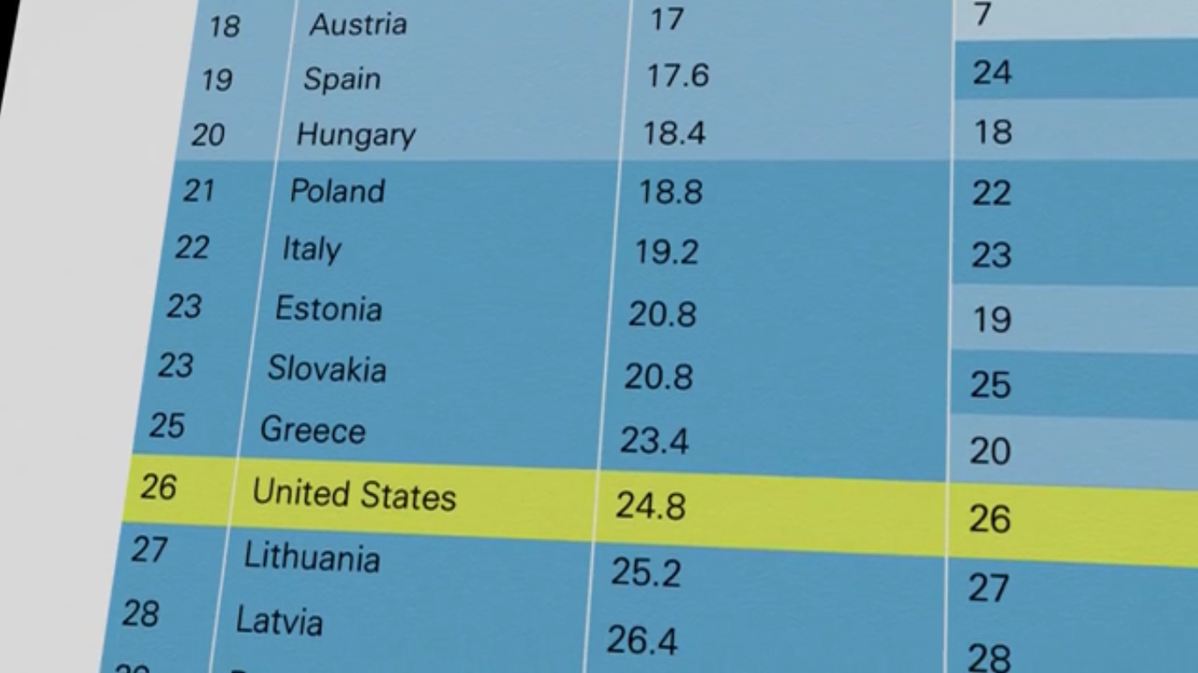
---------------------------------------------------------------------------------------------------------------------------
Americans work more hours than any other rich nation. Many families need both mom and dad to be working. How does this affect children’s health? Find out more by watching The Raising of America with us on <insert date and time> at <insert location>.
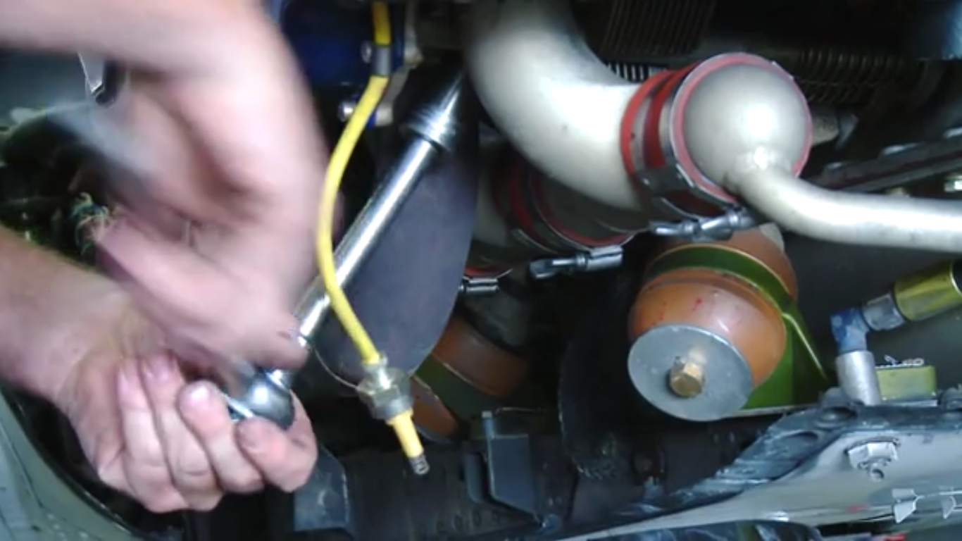
----------------------------------------------------------------------------------------------------------------------------
1 in 4 U.S. children are born into poverty. Join us on <insert date and time> at <insert location> to watch The Raising of America and discuss how we can reduce poverty. 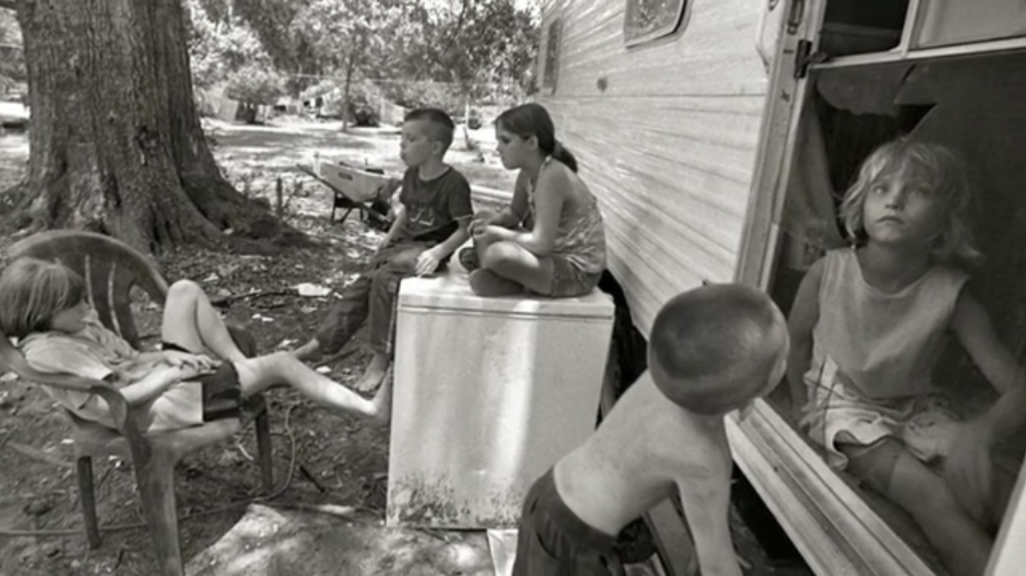
--------------------------------------------------------------------------------------------------------------------------------
Seventy percent of our children are growing up in families headed by working parents. Join us on <insert date and time> at <insert location> to watch The Raising of America and learn how this impacts child well-being.
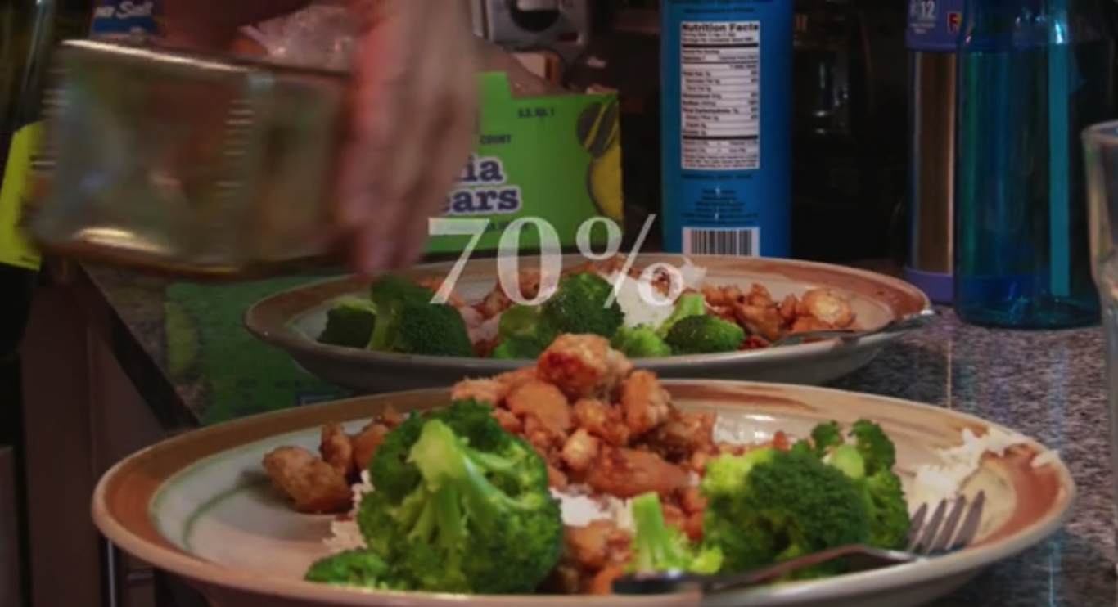
-----------------------------------------------------------------------------------------------------
Do U.S. policies discourage parents from being able to take care of kids well during prenatal and early years? Find out what researchers say by joining us on <insert date and time> at <insert location> to watch The Raising of America and learn about how policies affect how we raise our children.
-----------------------------------------------------------------------------------------------------------------------------
Of the wealthiest nations, the U.S. is the only nation that does not automatically provide paid maternity leave upon the birth of a child. What do you think about this? Join us on [insert date and time] at [insert location] to watch The Raising of America and voice your opinion and share ideas to improve the situation.
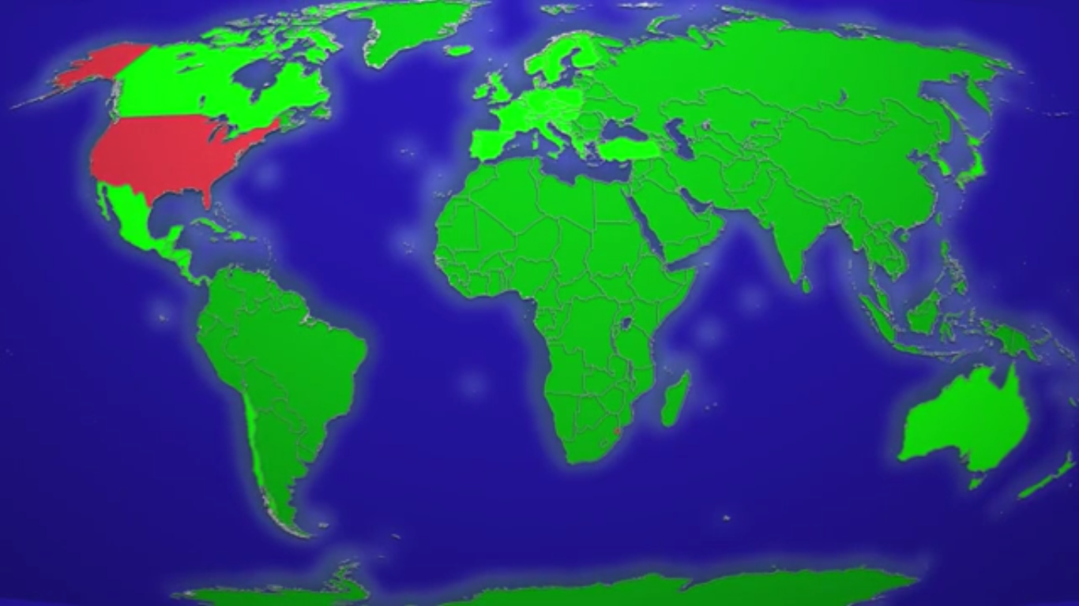
--------------------------------------------------------------------------------------------------------------------------------
40 percent of all American mothers are working within 3 months of their baby’s birth. Were/are you one of them? Is this good for mom, family, and baby? Join us on <insert date and time> at <insert location>to watch The Raising of America and learn about how we can improve child and family health in the U.S.
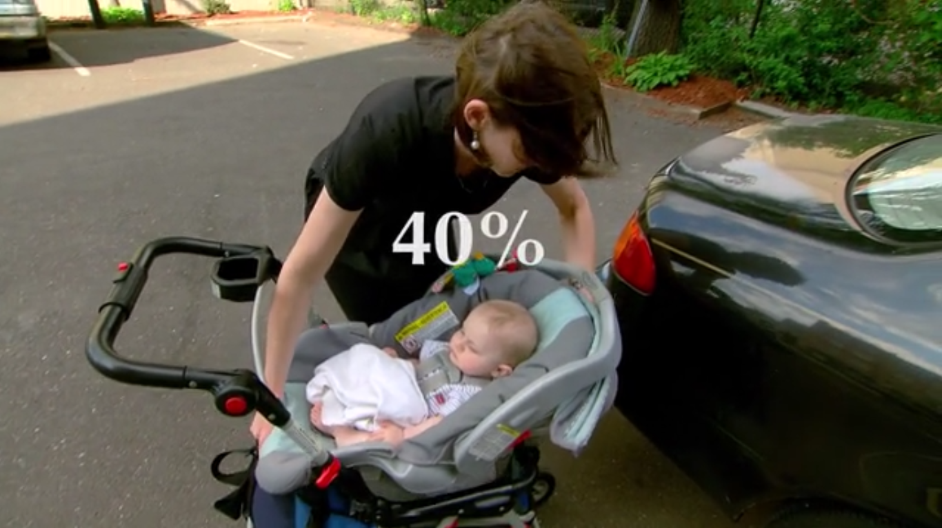
--------------------------------------------------------------------------------------------------------------------------------
Among rich nations, our childcare ranks 16th for affordability. Join us on <insert date and time> at <insert location> to watch The Raising of America and learn about how affordability of childcare is key to improving child health in the U.S.
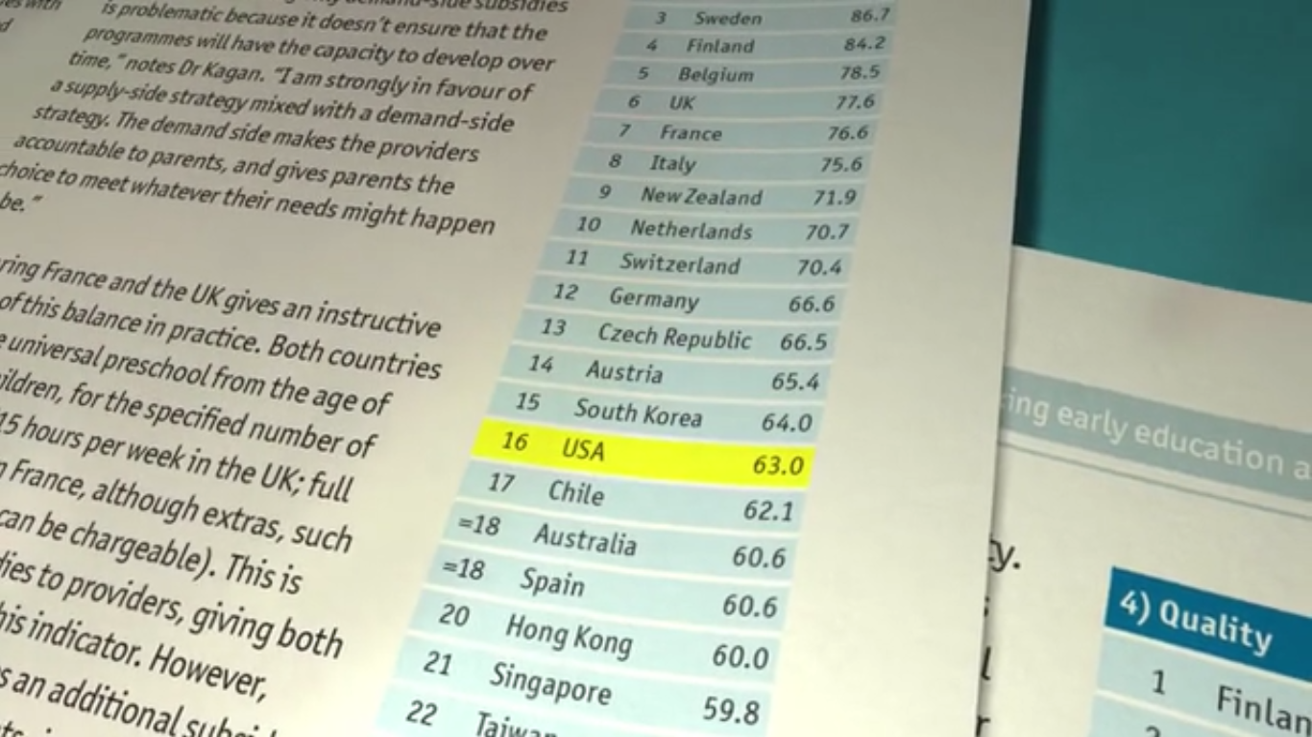
--------------------------------------------------------------------------------------------------------------------------------
Among rich nations, the U.S. ranks 22nd for child care quality. Join us on <insert date and time> at <insert location> to watch The Raising of America and learn about how the quality of childcare is key to improving child health in the U.S.
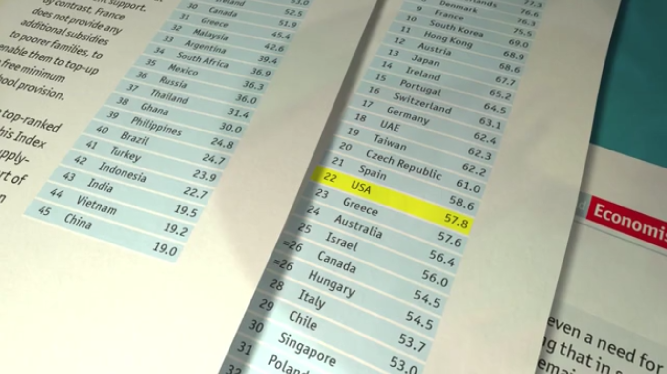
--------------------------------------------------------------------------------------------------------------------------------
Among rich nations, we rank 31st for availability of child care. Join us on <insert date and time> at <insert location> to watch The Raising of America and learn about how availability of childcare is key to improving child well being in the U.S.
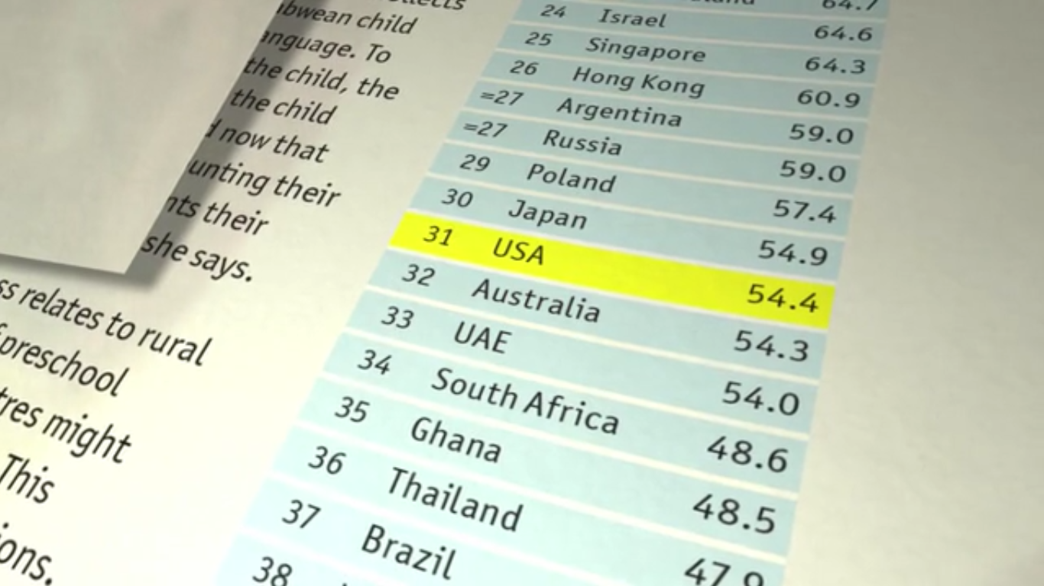
--------------------------------------------------------------------------------------------------------------------------------
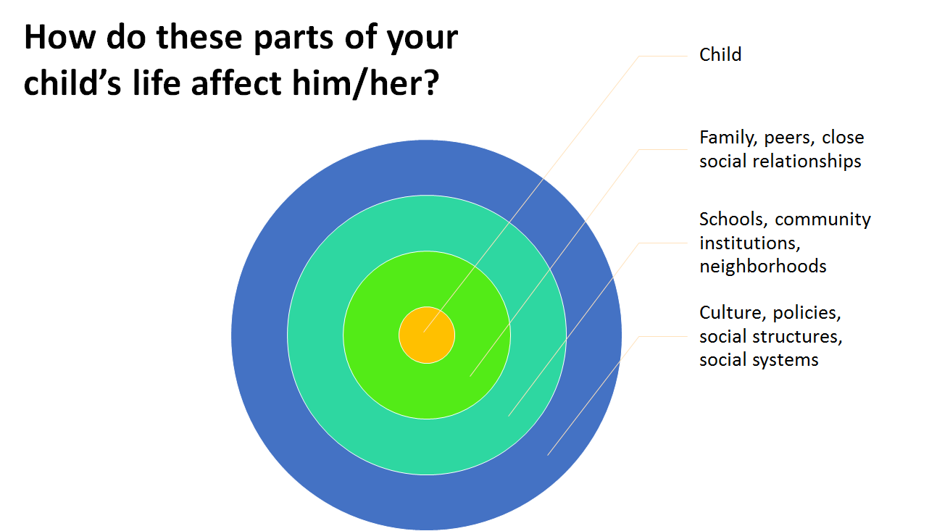
Join us on <insert date and time> at <insert location> to watch The Raising of America and share your thoughts.
--------------------------------------------------------------------------------------------------------------------------------
Where do you see the role of policies? Isn’t part of their role to help children grow and develop? Join us on <insert date and time> at <insert location> to watch The Raising of America and share your thoughts. Visit raisingofamerica.org.

Join us on <insert date and time> at <insert location> to watch The Raising of America and learn about why the U.S. is lagging in college completion and high school graduation. What does this mean for our future?
--------------------------------------------------------------------------------------------------------------------------------
Beginning from the moment of birth, 700 new brain synapses are created every single second in all parts of the brain that basically become the architecture--the foundation--of who we are as people. Join us on <insert date and time> at <insert location> to watch The Raising of America and learn more about how early childhood brain development is key to a child’s wellbeing.
--------------------------------------------------------------------------------------------------------------------------------
Everything starts at the bottom up. If we don’t do it right early, it’s harder later, we pay more for it later, and we don’t get as good an outcome. Join us on <insert date and time> at <insert location> to watch The Raising of America and learn about how to start off on the right foot.
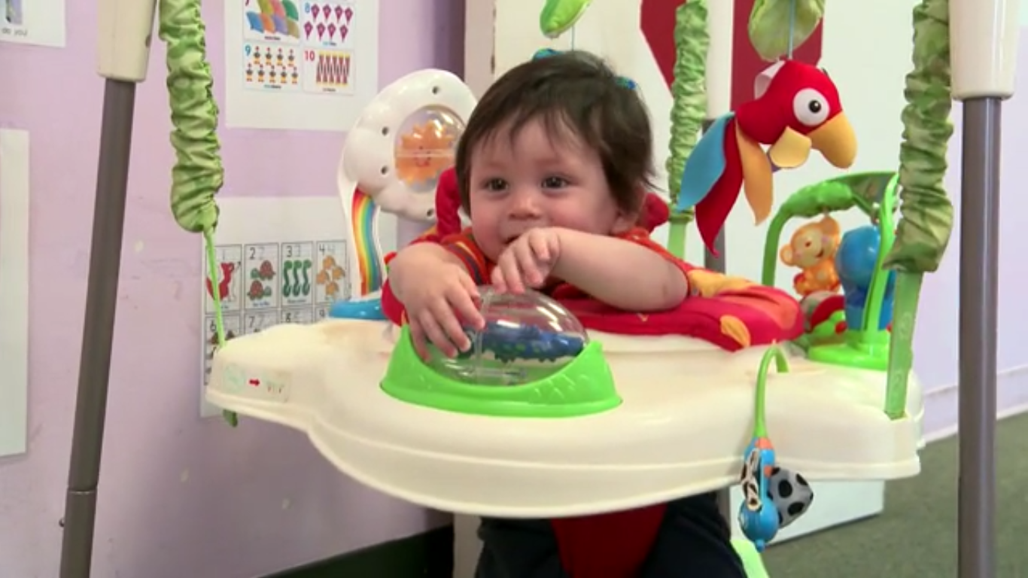
--------------------------------------------------------------------------------------------------------------------------------
The evidence is in. When we increase the time, income, and resources of parents and caregivers of young children, we help build a solid foundation for lifelong development--better learning, earning and physical and mental health. Join us on <insert date and time> at <insert location> to watch The Raising of America and discuss with us how to help build a solid foundation for our children.
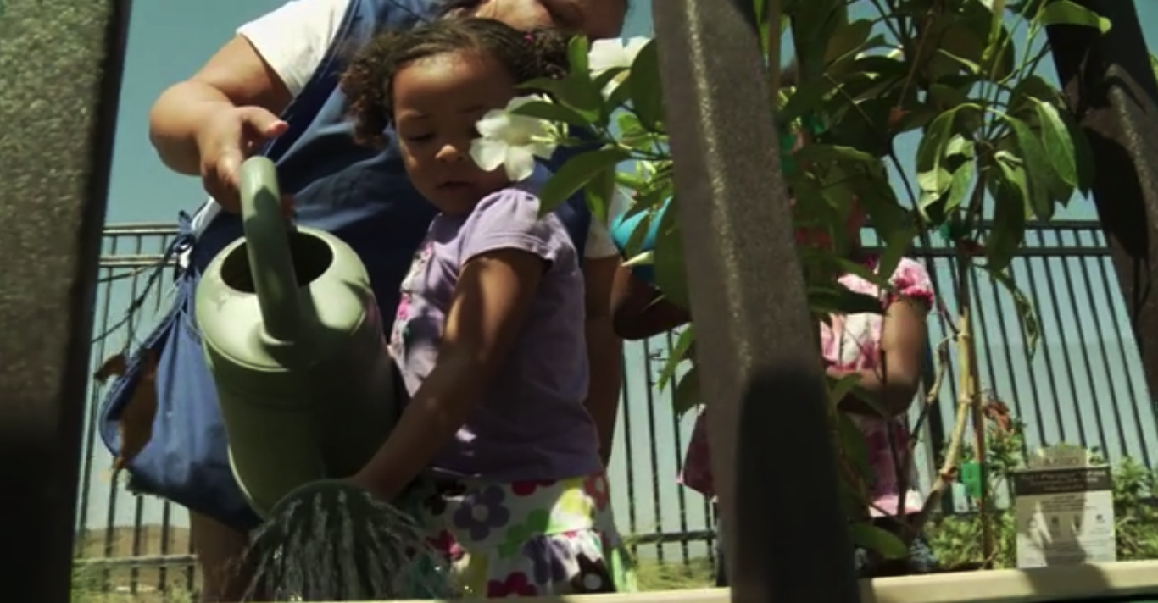
--------------------------------------------------------------------------------------------------------------------------
Check out the equation used by economist James Heckman for why we should invest in children. To learn more, visit: http://heckmanequation.org/heckman-equation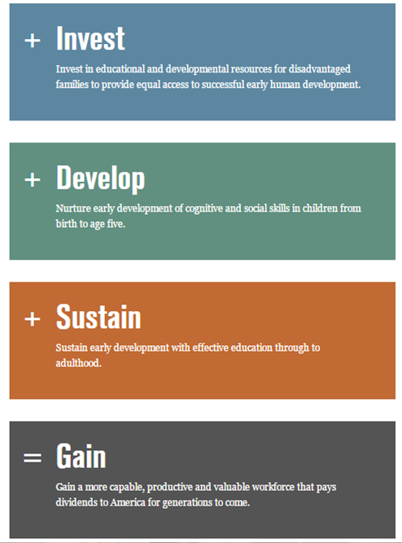
--------------------------------------------------------------------------------------------------------------------------------
Join <insert hosting agencies’ names here>in exploring how a strong start for all our kids can lead to a healthier, safer, better educated and more prosperous and equitable America. Join us on <insert date and time> at <insert location> to watch The Raising of America. Raisingofamerica.org.
New research shows that early experiences get under our babies’ skin and can alter the wirings in the developing brain for either better or worse. Join us on <insert date and time> at <insert location> to watch The Raising of America and learn more about how early experiences are key to a child’s development.

Sample Press Release

<Your Agency>
<Your Contact Information>

<Date>

FOR IMMEDIATE RELEASE

New Documentary Suggests U.S. is Nuts Not to Invest More in Our Youngest Children
The Raising of America interweaves the latest discoveries from neuroscience with the stories of families and communities doing all they can to provide the nurturing environments all babies and young children need to thrive. But too often individual efforts are hindered by social conditions that affect children’s developmental trajectories. If we aspire to a healthier, safer, better educated, more prosperous and equitable nation, we must invest in all our infants now.

In 2014, the Kids Count Data Center ranked Louisiana 47th out of 50 states for child well-being, using measures of risk for economic well-being, education, health, and family and community. According to Early Childhood Risk and Reach in Louisiana, Orleans Parish is ranked 49th out of 64 parishes in terms of the level of risk young children experience. Charlotte Parent, Director of City of New Orleans Health Department encourages all agencies—whether they are businesses, educators, or health and social services—to join the conversation about what we can do, individually and collectively, to promote, strengthen, expand, develop, and implement appropriate policies, services, programs and projects for families of Orleans Parish. In doing so, we can assure that every child may achieve his or her full potential. We owe this to our children.

In this five part series, The Raising of America explores how early care and education pays for itself many times over and how children living in or experiencing poverty, adversity, violence, neglect and other forms of trauma show symptoms similar to Post-Traumatic Stress Disorder.

Science has demonstrated that a child’s experiences during the earliest years are vital to building the foundation for lifelong individual success – in school and in life.

Studies by former Federal Reserve economist Arthur Rolnick, Nobel laureate James Heckman and others in this documentary conclude that high-quality early care and preschool are among the best investments the nation can make, yielding huge individual and societal benefits.

The Raising of America also travels to Quebec which rolled out a novel jobs and antipoverty program: they introduced universal early care and preschool for all children from birth to age five at a cost of $7 a day, along with expanded paid parental leave and other family supports.
Quebec child poverty rates fell from the highest in Canada to the lowest across the nation.

This documentary begs viewers to question how much they are willing to invest in their own future. By improving access to quality child care and early childhood education and supporting families who are confronting significant stressors on a daily basis, we will not only improve our children’s chances of thriving but also our own.

We invite you join in the conversation and movement to change our future, by attending a screening of The Raising of America on <insert date and time> at <location>. Please contact <insert information> to RSVP or with questions.

The Raising of America: Early Childhood and the Future of Our Nation
www.raisingofamerica.org is a production of California Newsreel www.newsreel.org with Vital Pictures, producers of the award-winning documentary series UNNATURAL CAUSES: Is Inequality Making Us Sick? www.unnaturalcauses.org. Major funding is provided by the W.K. Kellogg Foundation and The California Endowment.

Visit the documentary series’ temporary website at www.raisingofamerica.org for more about episodes or to get involved with The Raising of America public engagement campaign to change the national conversation around early childhood and our future health, prosperity, and equity.

The Raising of America
5 episodes: Signature Hour (60 minutes); Once Upon a Time (43 minutes); Are We Crazy about Our Kids? (32 minutes); Wounded Places (32 minutes); DNA is not Destiny (in development)
By California Newsreel with Vital Pictures
Producer / Director: James Rutenbeck
Associate producers: Franziska Blome, Elizabeth Shea
Senior Producer: Christine Herbes-Sommers
Series Creator and Executive Producer: Larry Adelman
www.raisingofamerica.org
-######-

Day of the Event
The following appendices are what you could use the day of your event to give to your attendees.

Sample Agenda
This outlines the general amounts of time we recommend for each section of the screening. Depending on the episode you select, the amount of time needed to screen the episode will vary.
15 min. Welcome & Introductions: Be sure to have all partnering agencies introduce themselves and highlight why you decided to screen this episode.

10 min. Ice-Breaker/Warm-Up Activity: This is a great way to get people thinking about some of the topics that will be discussed in the film. See appendix X for activities for each episode.

60 min. Screen Your Episode: Remember the episodes range anywhere from 32 to 60 minutes. Make sure people can see and hear the media well.

20 min. Moderated Panel Discussion/Speaker: You can find ideas for discussion questions in appendix X. If you have a panel, only spend a couple minutes on each prepared question. Maybe consider having specific panelists handle different questions.
OR
Open Discussion: Invite viewers to use their phones and tablets to write something on social media about what they just watched and how it struck them. Open up the conversation with a general question. Some ideas are below. Allow people to express their opinion, but make sure more than one person gets to speak.
  - What most surprised you about the episode?
  - Do you relate to anything in this episode?
  - What does this episode inspire you to do?
  - When thinking about your community in terms of this episode, what strikes you?

10 min. Calls to Action: Talk to your viewers about what they can do in response to this new information.
- Invite people to conduct a screening in their own neighborhood. (Share this toolkit with them.)
- Suggest the Calls to Action you developed while planning this screening.

5 min. Closing Remarks & Feedback: Thank everyone for coming and request they provide feedback about the screening experience using the form provided in this packet (appendix X) or another way.

<Insert partnering agencies’ logos at the bottom>

Sample Sign-In Sheet

Date:______________ Location:_____________________________ Episode Shown:______________________________

Name | Organization | Phone Number | Email
Please let Kristen Kirksey (kkirksey@nola.gov) know how many people attended the event.

Ice -Breaker Activities for Before the Screening
These are ideas for some activities you could do right after the opening of your screening event but before you play the documentary. These activities are a good way to “warm-up” your audience and to buy some time if people are running late. All activities are taken directly from The Raising of America’s discussion guides. You can find additional activities and ideas at raisingofamerica.org.

Agree or Disagree: Signature Episode or “Once Upon A Time”
There are several options for getting responses to this activity:
- Distribute a handout and invite people to write down answers
- Create an agree/disagree line on the floor and ask people to physically move to the spot on the line that indicates their view as you read aloud one or more of the statements
- Read aloud one or more of the statements and give people a moment to think about what their response is.

Statements
On a scale of 1-10, do you agree or disagree with these statements?
(1 =”don’t agree at all, not even a little bit”; 10 =“wholeheartedly agree”)
- People who can’t afford to raise children shouldn’t have them.
- Anyone in the U.S. who works hard and makes responsible choices can improve their economic status without government help.
- Government assistance to families produces greater payoffs than government programs or policies designed to create a favorable investment climate for Wall Street.
- It’s easier today for most young families to provide for their babies’ and children’s well-being than it was 60 or 70 years ago.
- Some income inequality is desirable, but when the gap grows too large, it threatens American democracy.
- Children are our future, so government has a responsibility to invest in their well-being.
- Social programs designed to combat poverty are more likely to instill a sense of dependence on government than to help people improve their economic situation.
- The Constitution’s guarantee of “life, liberty, and the pursuit of happiness” means that individual families should be able to raise their children without any government interference.
- Pre-K should be universally available at no charge to all children, just as K-12 is now.
- Mothers (or fathers) should stay home and take care of their young children until they enter kindergarten.

Multiple Choice Quiz: Are We Crazy About Our Kids?
Take the quiz below, individually or in small groups. Review the answers after the screening and compare them with what the film says.
- Over the lifetime of a child, government spending on high quality early care and education will result in a net financial gain or loss of how much?
  - loss of $5 for every dollar invested
  - loss of $1.50 for every dollar invested
  - breaks even
  - gain of $3 for every dollar invested
  - gain of $7 for every dollar invested
- What percentage of U.S. child care facilities are accredited?
  - none
  - 10%
  - 45%
  - 70%
  - all
- Québec, our Canadian neighbor to the north, reduced their child poverty rate by offering:
  - child care and preschool at $7 a day, birth to age 5
  - paid maternity leave for 11 months (some sharable with fathers)
  - decreased taxes for families with children
  - incentives to businesses to offer a family wage, so a single earner could support a family while their spouse remained at home to care for the couple’s children
  - all of the above
  - a & b
  - c & d
- On average, a parent of a four-year-old in the U.S. who was not eligible for subsidies could expect to pay _______ for center-based care:
  - less than $5,000 per year
  - $5,000-$10,000 per year
  - $10,000-$15,000 per year
  - more than $15,000 per year
- Research shows that children who receive high-quality early care and education:
  - are more likely to be identified as in need of special education services and tracked into special education in elementary school.
  - are less likely to need special education services in elementary school.
  - are neither more nor less likely to need special education. Quality of early care does not have a measurable impact on whether or not a child is identified as having special needs.
ANSWERS: 1e; 2b; 3f; 4c; 5b

Ranking Exercise: Are We Crazy About Our Kids? & Signature Hour
Ask people to consider their own experience with child care and/or preschool:
- On a scale of 1-10, with 10 being really easy, how easy was it for you to find child care?

- On a scale of 1-10, with 10 being excellent, how would you rate the quality of care available?

- Approximately what percentage of your income did you pay/are you paying for child care?

- Has lack of child care ever prevented you from going to work? If so, describe.

- Was maternity or paternity leave available to you, and if so, did you take it? For how many weeks?

- On a scale of 1-10 with 10 being the very easy, how feasible was it/is it for you to take three months of parental leave under current policies?

Visualization Activity: Wounded Places
In sixty seconds or less, describe a person (either on paper or in your “mind’s eye”) who comes to mind when you hear this term: PTSS (post-traumatic stress syndrome). Share with the group. What are the most common images? As you view the film, consider what you left out.

Root Causes Activity: Wounded Places
Which of these things do you think of as a contributing cause of Post-Traumatic Stress Syndrome?
- Engaging in combat/being on a battlefield
- Witnessing real-life violence
- Seeing graphic media violence
- Not being allowed to play outside because your parent fears violence
- Child abuse and neglect
- Experiencing racism or similar injustices
- Poverty
- Living in a concrete jungle (no green space)
- Segregation
- Famine
- Chronic hunger (food is generally available, but not to you)
- Chronic lack of sleep
- Overcrowded and sub-standard housing
- Family substance abuse
- Witnessing or being in a terrible accident such as a plane crash
- Living through a natural disaster such as an earthquake or hurricane
- Being homeless
- Loss of a parent
- Being bullied

Sample Discussion Questions
Here are some questions you could use to spur discussion after the film. The questions are broken down by episode. Most questions are taken directly from the discussion guides provided by raisingofamerica.org. Please visit their website if you would like additional questions.

The Raising of America Signature Hour
- What can we do to strengthen the capacity of everyone who works with children so they can provide what children need?
- How can we strengthen the capacity of families and their communities to provide a safe and nurturing environment to raise children?
- What kind of role could business play to support the people who work for them?
- Instead of blaming government programs, we should ask "How can we do a better job?" So, how can we do a better job?

Once Upon a Time
- How would providing affordable, accessible, high quality universal childcare help people move into or keep their status as part of the middle class?
- How might the nation be different today if high-quality universal child care had been available to all for the past four decades?
- What are ways we could advocate for access to high quality child care, both locally and nationally?

Are We Crazy About Our Kids?
- Arthur Rolnick looks at early childhood expenditures and asks a common business question: “What was the return on the investment?” How would you answer the question? What do you hope the return on investment would be?
  - Does your answer include any non-monetary benefits?
- Québec’s parental leave laws give all mothers the option to take 50 weeks of paid maternity leave at 75% of their salary, and most of the leave can be shared with the father. Why would parental leave policies be an economic benefit rather than simply an added expense for employers?
  - How might attitudes towards parental leave policies be affected by framing them as a benefit that a nation grants to each of its children rather than as an extra benefit that employers grant to parents?
- In Québec, early care and preschool and other services from birth to age five are universal, i.e. they are offered to all families who want them. There is a debate in the U.S. whether initiatives like high-quality early care, pre-K and home visiting nurses should be made available for free or low cost only for children of low income families, or for all children. What are the arguments for both sides? Where do you stand?
- The positive results described in the film are not attributable to all child care, but rather, to the very specific high-quality models from the Perry, Abecedarian and Chicago case studies. What did you notice about the specific features of those projects that contributed to children’s and families’ success?
- Of all the possible strategies to deal with skyrocketing social welfare or special education costs, where would you rank investments in early care and education? What evidence supports your ranking?
- If society, as a whole, benefits from investing in affordable and high-quality child care and preschool, why do we continue to leave it to individual parents to cover the lion’s share of costs for child care and preschool?
  - What are the costs to society when high-quality care is unaffordable for most parents?

Wounded Places
- Olis Simmons invokes the adage “hurt people hurt people.” She says, “Violence is not the problem. It’s the symptom of the problem. The people with the greatest need have the least resources. Have the least skilled teachers, the least outdoor space, the least music, the least recreation, the least art, the least of all of it, when they have the greatest need. And they know that other people have it and they don’t. We can’t have whole communities of people locked out of economic opportunity, undereducated, under and unemployed and believe that we can continue to thrive, because it’s just not possible.”
  - Why can’t society as a whole thrive when whole communities are locked out of economic and educational opportunities?
  - How does the sense that they are being devalued and excluded contribute to the stress experienced by children in poor neighborhoods?
- Besides violence, what other adverse experiences increase the risk of PTSS in poor communities?
  - What other adversities do poor communities of color face?
  - How does racism create or add to the risk?
- Physician John Rich explains shifting definitions of trauma: “It used to be we thought about trauma as someone being in a plane crash, or someone having a gunshot wound. Those are types of trauma, but more generally, we can talk about trauma as when the strengths inside you and the resources around you can’t respond to a threat.” What does this mean? Can you give an example?
  - What could be done, both in your community and from a policy perspective to help children build the “strengths inside” that would enable them to thrive?
  - What could be done to reduce the threats that feed the trauma in the first place?
- In addition to interventions aimed at helping injured children heal, what could be done to help parents like Christine and Antonio?
  - Why would it be important for children’s well-being to ensure the well-being of their parents or guardians?
- What is your reaction to the film’s conclusion that “healing the hurt of young people … means confronting the racial segregation, disinvestment and lack of jobs and decent, safe housing, which generate suffering rather than hope for so many American children and families”?
  - What do you imagine that confrontation would look like?
- How would asking “What happened to this person?” instead of “What’s wrong with this person?”: change the way you approach discipline?
  - Change the way you think about how to help children living in poor or neglected neighborhoods?
  - Change your approach to combating poverty, racism, substance abuse, or violence?
  - Change your relationship to the families of the children with whom you work?
- The film asks, “Instead of labeling them as ‘bad kids,’ why don’t we see them as children facing adversities that other children don’t?”
  - How would you answer that question?
  - What is your school district doing to implement alternatives to suspension?
  - What could help early childhood professionals develop the capacity to help traumatized children rather than expelling them?
  - What professional development does the district provide for working with children who have experienced chronic trauma?
  - What additional training would you like to receive?

Contact Information for Elected Officials in Orleans Parish
One of your Calls to Action could be writing a letter to an elected official. These tables includes the names and contact information for Louisiana and U.S. Congress.

Louisiana State Senate
Name | Title | Party | Contact Information
Karen Carter Peterson | Senator, Louisiana State Senate (District 5)  Chairman, Women and Children Committee | Democrat | 1409 Oretha Castle Haley Blvd.  Suite C  New Orleans, LA 70113  petersonk@legis.la.gov  504-568-8346
Jean-Paul (JP) Morrell | Senator, Louisiana State Senate (District 3)  Member, Education Committee | Democrat | 6001 Stars & Stripes Blvd.  Suite 221  New Orleans, LA 70126  morrelljp@legis.la.gov  504-284-4794
Conrad Appel | Senator, Louisiana State Senate (District 9)  Chairman, Education Committee | Republican | 721 Papworth Ave.  Suite 102A  Metairie, LA 7005  appelc@legis.la.gov  504-838-5550
David R. Heitmeier, O.D. | Senator, Louisiana State Senate (District 7)  Chairman, Health & Welfare Committee | Democrat | 3501 Holiday Dr.  Suite 225  New Orleans, LA 70114  heitmeierd@legis.la.gov  504-361-6356
Edwin R. Murray | Senator, Louisiana State Senate (District 4)  Vice-Chairman, Labor & Industrial Relations Committee  Member, Women & Children | Democrat | 1540 N. Broad  New Orleans, LA 70119  murraye@legis.la.gov  504-945-0042
- G. Crowe | Senator, Louisiana State Senate (District 1)  Chairman, Labor & Industrial Relations Committee | Republican | 646 Carnation Street  Slidell, LA 70459  crowea@legis.la.gov  985-643-3600

Louisiana House of Representatives
Name | Title | Party | Contact Information
Neil C. Abramson | Representative, Louisiana House of Representatives (District 98) | Democrat | 601 Poydras Street  Suite 1635  New Orleans, LA 70130  abramson@legis.la.gov  504-275-8051
Jeffery “Jeff” Arnold | Representative, Louisiana House of Representatives (District 102) | Democrat | 3520 General DeGaulle  Suite 3071  New Orleans, LA 70114  larep102@legis.la.gov  504-361-6600
Austin J. Badon, Jr. | Representative, Louisiana House of Representatives (District 100) | Democrat | 5555 Bullard Ave.  Suite 101  New Orleans, LA 70128  larep100@legis.la.gov  504-243-7783
Wesley T. Bishop | Representative, Louisiana House of Representatives (District 99)  Member, Education Committee | Democrat | 7240 Crowder Blvd.  Suite 402  New Orleans, LA 70127  bishopw@legis.la.gov  504-242-4198
Joseph Bouie Jr. | Representative, Louisiana House of Representatives (District 97) | Democrat | 6305 Elysian Fields Ave.  Suite 400  New Orleans, LA 70122  bouiej@legis.la.gov  504-286-1033
Raymond E. Garofalo, Jr. | Representative, Louisiana House of Representatives (District 103) | Republican | 9000 W. St. Bernard Hwy.  Suite 40  Chalmette, LA 70043  garofalor@legis.la.gov  504-277-4729
Walt Leger, III | Representative, Louisiana House of Representatives (District 91)  Member, Education Committee  Ex Officio, Health & Welfare Committee  Ex Officio, Labor & Industrial Relations | Democrat | 935 Gravier St.  Suite 2150  New Orleans, LA 70112  legerw@legis.la.gov  504-556-9970
Christopher J. Leopold | Representative, Louisiana House of Representatives (District 105) | Republican | 1500 Woodland Hwy.  Suite A  Belle Chasse, LA 70037  leopoldc@legis.la.gov  504-393-5649
Nick Lorusso | Representative, Louisiana House of Representatives (District 94) | Republican | 3535 Canal Street  Suite 103  New Orleans, LA 70119  larep094@legis.la.gov  504-483-4711
Helena N. Moreno | Representative, Louisiana House of Representatives (District 93) | Democrat | 643 Magazine St.  Suite 302  New Orleans, LA 70130  morenoh@legis.la.gov  504-569-2740

U.S. House of Representatives
Name | Title | Party | Contact Information
Steve Scalise | Congressman, U.S. House of Representatives (1st District of LA) | Republican | 2338 Rayburn HOB  Washington DC 20515  202-225-3015
Cedric Richmond | Congressman, U.S. House of Representatives (2nd District of LA) | Democrat | 240 Cannon HOB  Washington DC 20515  202-225-6636

U.S. Senate
Name | Title | Party | Contact Information
Bill Cassidy | Senator, U.S. Senate  Member, U.S. Senate Committee on Health, Education, Labor and Pensions | Republican | 703 Hart Senate Office Building  Washington DC 20510  www.cassidy.senate.gov/content/contact-bill  202-224-5824
David Vitter | Senator, U.S. Senate | Republican | 516 Hart Senate Office Building  Washington DC 20510  www.vitter.senate.gov/contact  202-224-2623

General Letter Format for a Letter to Elected Officials
If you choose to have participants write a letter to elected officials, you can use this general format to create a letter for participants to follow. We would recommend that you draft the letter ahead of time for your attendees, highlighting the key concept you want your elected officials to know about. This sample letter was found at http://www.ala.org/aasl/sites/ala.org.aasl/files/content/aboutaasl/aaslcommunity/quicklinks/el/Sample_Letter_to_Elected_Officials.pdf, and all facts are pulled from The Raising of America website.
<Date >
<Your Name>
<Your Address>
<Your City, State, Zip code>
<Your E-mail>
<Your Phone Number>

The Honorable <Insert Elected Official’s Name>
<Select House of Representatives or United States Senate Office>
<Address of Representative or Senator >

Dear <Representative/Senator Name>,

(In your first paragraph include personal information). Example: I am very fortunate to have been provided with an excellent education that prepared me for the future. I currently have children in both elementary and middle school. Recently, I have become very concerned about why the U.S. ranks 26th out of 29th rich nations in child well-being and how little money is invested in our youngest residents during their first few years of life. As a parent yourself, I am sure that you share many of these concerns.

(Include facts) According to studies of Perry Preschool and other programs by Nobel economist James Heckman, there is a 7-10% per year return over the lifetime of each child for each dollar invested in early interventions, such as quality child care and early education programs. Other studies conclude a return of $6 to $17 for every dollar invested in high-quality programs as a result of better education, increased productivity and decreased social costs. In dollar terms, the Chicago Parent-Child Center and Abecederian studies calculated a return to society of $84,000 and $100,000 respectively after the costs of the programs were subtracted. In Quebec, the government gets back $1.04 from increased tax revenues alone for every $1 it invests in its child care system because so many more mothers (and some fathers) are now able to work. The new documentary, The Raising of America looks at many of the economic and societal benefits to investing in early childhood education and quality child care.

(State what you are asking for) I ask that you support <Insert name of bill here>. In supporting this bill will increase funding in early childhood education programs and quality child care across the nation. This is a very small price to invest in the futures of our nation’s children. All children should have the opportunity to achieve and develop skills necessary for the future. I believe that in supporting this bill you will impact the lives of countless children.

Sincerely,
<Signature)>
<Your Name>

Sample Letter Regarding Paid Leave
If you choose to have participants write a letter to elected officials about the importance of paid leave, you can use this letter created by Evolutionary Parenting. This letter is also available online at http://evolutionaryparenting.com/download-letter-to-us-representatives-re-maternity-leave/.
<Date >
<Your Name>
<Your Address>
<Your City, State, Zip code>
<Your E-mail>
<Your Phone Number>

The Honorable <Insert Elected Official’s Name>
<Select House of Representatives or United States Senate Office>
<Address of Representative or Senator >

Dear <Representative/Senator Name>,
I am writing you to ask that you help families by working to increase both the amount of maternity leave allotted and to provide paid leave to new mothers in [INSERT STATE HERE]. I understand that the Family and Medical Leave Act allows employees up to 12 weeks of unpaid leave, although only six weeks of short term disability may be given. Therefore, for many families, six weeks can be the only amount of time they can afford to take off with their newborn babies. With many families relying on two incomes to survive, a program (in this case, the FMLA) that does not provide for any compensation is one that becomes non-viable for many of the people it is designed to help. As few states have any policies in place to improve upon the FMLA, it remains the centerpiece of US maternity leave policy.

Compare this to the more than 100 countries that allow a minimum of 12 weeks of paid parental leave. For example, Canada allows 50 weeks of parental leave at a salary of 55% up to maximum and an extra two weeks unpaid leave. In Europe most countries allow 14 weeks of paid leave. France allows 16 weeks fully paid with 2 years unpaid and your job guaranteed. Germany allows 14 weeks fully paid or 12 months at 67% and up to 3 years unpaid. Norway allows 56 weeks paid at 80% or 46 weeks at 100% paid. In this realm, the United States is far behind other developed nations with similar economies. It’s about time we realized what other countries already know–the importance of maternity leave on not only a strong family, but a strong nation.

What does a longer parental leave offer families? To begin, it would afford more mothers the time needed to develop a breastfeeding relationship with their child. The effects of suboptimal breastfeeding rates in the United States have been well-documented, with a 2009 review by Drs. Bartick and Reinhold in the journal Pediatrics suggesting that if the US could get 80% of mothers to follow the World Health Organization’s guidelines of exclusively breastfeeding for six months, the government would save $10.5 billion per year in health care costs while also saving 741 lives, the vast majority of whom would be under the age of one. It has been well-documented that the early return to work that is common in the United States has a direct effect on the length of time that women breastfeed, with earlier returns to work resulting in earlier weaning times (e.g., Biagioli, 2003; Duckett, 1992; Ogbuanu, Glover, Probst, Liu, & Hussey, 2011).

A second benefit is that it can reduce the rates of post-partum depression (PPD) and other psychological disorders plaguing many mothers. While PPD was long-considered solely an effect of hormones released post-birth, our understanding of the disorder has changed and we’ve realized that it is highly influenced by environmental factors. Support and sleep being two of the biggest (e.g., Dennis & Ross, 2005; Dørheim, Bondevik, Eberhard-Gran, & Bjorvatn, 2009). For mothers who have to return to work after six weeks, or even twelve, they suddenly find themselves working all day then returning to an infant they have to bond with and care for, meaning they get very little sleep and are often overworked with little instrumental support, increasing the likelihood of suffering PPD. Not to mention that the bonding process has been prematurely interrupted making it harder for both mother and infant to adjust to each other.

A third benefit pertains to the development of a secure attachment between infant and mother. Infants with a secure attachment to their caregivers are not only more sociable and cry less (e.g., Bell & Ainsworth, 1972; van den Boom, 1994), but perhaps most importantly, are far less likely to be abused (for a review, see Morton & Browne, 1998). In 2010 3.6 million children suffered abuse in the United States, with the highest rates being for infants. More than 80% of the time, the perpetrators were the child’s parents. Child abuse and neglect is a great concern and while there are already funds allocated towards prevention of neglect and abuse I believe—and research supports—that increasing the amount of maternity leave can reduce abuse and neglect rates. In one study, there was a linear relationship between the length of maternity leave and the quality of the attachment between the mother and child (including positive affect and positive behaviours) (Clark, Hyde, Essex, & Klein, 1997). Breastfeeding, which I have already covered as being important to infant health, has also been found to increase bonding between mother and child (Else-Quest, Hyde, & Clark, 2003), and serves as an independent protective factor in abuse (Strathern, Mamun, Najman, & O’Callaghan, 2009). I believe that allowing for a strong attachment relationship to form will create a successful child who will become an important contributor to society.

A fourth benefit is increased gender equality in the work place. Providing a protected period of time for which women can recuperate from birth and form the necessary bonds with her child increases the chances that she will not only return to work, but return less stressed and more focused (Burgess, Gregg, Propper, & Washbrook, 2008). It also reduces the chance that she will suffer long-term pay differentials with her male and childless female counterparts (Waldfogel, 1998a, 1998b). While the gender gap in pay inequality has been steadily decreasing, an opposite trend has emerged for women with children who are facing larger pay gaps between themselves and childless female workers. Finding ways to reduce this gap is essential for the well-being of families in the United States.

Because of these factors, I strongly urge you to re-introduce legislation concerning paid maternity and paid family leave in the 2016 legislative session. Our babies are the biggest sufferers from current maternity leave standards and for a country that speaks of “family values” we are failing to live up to that ideal. Our children are the future of the nation and we need to give them the best start at life, we need to give them what they deserve. Increasing the time allowed for maternity leave would help to improve breastfeeding rates, reduce post-partum depression, reduce child neglect and abuse by improving parent – child attachment, and improve working mothers’ standing in the work force while increasing the chances that they return and feel invested in returning to work.

Thank you for your consideration. Please contact me if you have any further questions or concerns.

Sincerely,
<Signature)>
<Your Name>

References Cited Herein
Bartick M, Reinhold A. The burden of suboptimal breastfeeding in the United States: a pediatric cost analysis. Pediatrics 2009; 125: 1048-56.
Bell SM, Ainsworth MDS. Infant crying and maternal responsiveness. Child Development 1972; 43: 1171-90.
Biagioli F. Returning to work while breastfeeding. Am Fam Physician 2003; 68: 2201-8.
Burgess S, Gregg P, Propper C, Washbrook E. Maternity rights and mothers’ return to work. Labour Economics 2008; 15: 168-201.
Clark R, Hyde JS, Essex MJ, Klein MH. Length of maternity leave and quality of mother-infant interactions. Child Development 1997; 68: 364-83.
Dennis C-L, Ross L. Relationships among infant sleep patterns, maternal fatigue, and the development of depressive symptomology. Birth 2005; 32: 187-93.
Dørheim SK, Bondevik GT, Eberhard-Gran M, Bjorvatn B. Sleep and depression in postpartum women: a population-based study. Sleep 2009; 32: 847-55.
Duckett L. Maternal employment and breastfeeding. NAACOG’s clinical issues in perinatal and women’s health nursing 1992; 3: 701-12.
Else-Quest NM, Hyde JS, Clark R. Breastfeeding, bonding, and the mother-infant relationship. Merrill-Palmer Quarterly 2003; 49: 495-517.
Morton N, Browne KD. Theory and observation of attachment and its relation to child maltreatment: a review. Child Abuse & Neglect 1998; 22: 1093-1104.
Ogbuanu C, Glover S, Probst J, Liu J, Hussey J. The effect of maternity leave length and time of return to work on breastfeeding. Pediatrics 2011; 127: e1414-e1427.
Strathearn L, Mamun AA, Najman JM, O’Callaghan MJ. Does breastfeeding protect against substantiated child abuse and neglect? A 15-year cohort study. Pediatrics 2009; 123: 483-93.
van den Boom DC. The influence of temperament and mothering on attachment and exploration: an experimental manipulation of sensitive responsiveness among lower-class mothers with irritable infants. Child Development 1994; 65: 1457-77.
Waldfogel J. The family gap for young women in the United States and Britain: can maternity leave make a difference? Journal of Labor Economics 1998a; 16: 505-45.
Waldfogel J. Understanding the “family gap” in pay for women with children. The Journal of Economic Perspectives 1998b; 12: 137-56.

Local Data
You can use these hand-outs to help people contextualize the data given in the film with data at a state and neighborhood level. This section includes data for the following neighborhoods: Little Woods, Read Boulevard East, Read Boulevard West, Plum Orchard, Lower Ninth Ward, Hollygrove, Dixon, Gert Town, B.W. Cooper, and Behrman. If you would like information on additional neighborhoods, please find it at http://nola.gov/getattachment/Health/Data-and-Publications/Child-and-Family-Health-in-New-Orleans-December-2013.pdf/.

Behrman

Ranks 31st out of 73 neighborhoods in New Orleans for child and family well-being
742 children under the age of 5 years live here.
Indicator | Behrman | New Orleans | Louisiana | U.S.
% babies born weighing under 5.5 pounds (the best predictor of infant mortality) | 13% | 12% | 11% | 8%
Median income in percentage points above or below the Federal Poverty Level | 82 % points above | 117 % points above | 156 % points above | 206 % points above
Percent of families experiencing a housing burden by paying more than 30% of their income on housing per month | 65% | 63% | 30% | 47%
Percent of children under the age of 18 years living in poverty | 42% | 39% | 29% | 21%
Unemployment Rate | 13% | 11% | 8% | 9%
Percentage of births to mothers with less than a high school diploma | 36% | 22% | 21% | 17%
Percentage of children ages 3-4 years enrolled in preschool | 51% | 7% | 7% | 6%
Number of childcare facilities per 100 children 5 years and under | 1.5 | N/A | N/A | N/A
Homicide rate (number of homicides per 100,000 population) | 54 | 40 | 12 | 5
Percentage of births to unmarried women | 65% | 64% | 49% | 36%
Percentage of births to teenage mothers | 15% | N/A | N/A | N/A

Neighborhood rate is better than the Parish rate

Neighborhood rate is worse than the Parish rate

B.W. Cooper

Ranks 55th out of 73 neighborhoods in New Orleans for child and family well-being
87 children under the age of 5 years live here.
Indicator | B.W. Cooper | New Orleans | Louisiana | U.S.
% babies born weighing under 5.5 pounds (the best predictor of infant mortality) | 16% | 12% | 11% | 8%
Median income in percentage points above or below the Federal Poverty Level | 32 % points BELOW | 117 % points above | 156 % points above | 206 % points above
Percent of families experiencing a housing burden by paying more than 30% of their income on housing per month | 40% | 63% | 30% | 47%
Percent of children under the age of 18 years living in poverty | 16% | 39% | 29% | 21%
Unemployment Rate | 39% | 11% | 8% | 9%
Percentage of births to mothers with less than a high school diploma | 36% | 22% | 21% | 17%
Percentage of children ages 3-4 years enrolled in preschool | N/A | 7% | 7% | 6%
Number of childcare facilities per 100 children 5 years and under | 0 | N/A | N/A | N/A
Homicide rate (number of homicides per 100,000 population) | 83 | 40 | 12 | 5
Percentage of births to unmarried women | 97% | 64% | 49% | 36%
Percentage of births to teenage mothers | 0% | N/A | N/A | N/A

Neighborhood rate is better than the Parish rate
Neighborhood rate is worse than the Parish rate

Dixon

Ranks 62nd out of 73 neighborhoods in New Orleans for child and family well-being
166 children under the age of 5 years live here.
Indicator | Dixon | New Orleans | Louisiana | U.S.
% babies born weighing under 5.5 pounds (the best predictor of infant mortality) | 8% | 12% | 11% | 8%
Median income in percentage points above or below the Federal Poverty Level | 3 % points BELOW | 117 % points above | 156 % points above | 206 % points above
Percent of families experiencing a housing burden by paying more than 30% of their income on housing per month | 69% | 63% | 30% | 47%
Percent of children under the age of 18 years living in poverty | 52% | 39% | 29% | 21%
Unemployment Rate | 14% | 11% | 8% | 9%
Percentage of births to mothers with less than a high school diploma | 42% | 22% | 21% | 17%
Percentage of children ages 3-4 years enrolled in preschool | 76% | 7% | 7% | 6%
Number of childcare facilities per 100 children 5 years and under | 0.6 | N/A | N/A | N/A
Homicide rate (number of homicides per 100,000 population) | 131 | 40 | 12 | 5
Percentage of births to unmarried women | 77% | 64% | 49% | 36%
Percentage of births to teenage mothers | 26% | N/A | N/A | N/A

Neighborhood rate is better than the Parish rate
Neighborhood rate is worse than the Parish rate

Gert Town

Ranks 46th out of 73 neighborhoods in New Orleans for child and family well-being
231 children under the age of 5 years live here.
Indicator | Gert Town | New Orleans | Louisiana | U.S.
% babies born weighing under 5.5 pounds (the best predictor of infant mortality) | 17% | 12% | 11% | 8%
Median income in percentage points above or below the Federal Poverty Level | 56 % points ABOVE | 117 % points above | 156 % points above | 206 % points above
Percent of families experiencing a housing burden by paying more than 30% of their income on housing per month | 81% | 63% | 30% | 47%
Percent of children under the age of 18 years living in poverty | 63% | 39% | 29% | 21%
Unemployment Rate | 25% | 11% | 8% | 9%
Percentage of births to mothers with less than a high school diploma | 31% | 22% | 21% | 17%
Percentage of children ages 3-4 years enrolled in preschool | 66% | 7% | 7% | 6%
Number of childcare facilities per 100 children 5 years and under | 1.3 | N/A | N/A | N/A
Homicide rate (number of homicides per 100,000 population) | 74 | 40 | 12 | 5
Percentage of births to unmarried women | 89% | 64% | 49% | 36%
Percentage of births to teenage mothers | 7% | N/A | N/A | N/A

Neighborhood rate is better than the Parish rate
Neighborhood rate is worse than the Parish rate

Hollygrove

Ranks 65th out of 73 neighborhoods in New Orleans for child and family well-being
385 children under the age of 5 years live here.
Indicator | Hollygrove | New Orleans | Louisiana | U.S.
% babies born weighing under 5.5 pounds (the best predictor of infant mortality) | 18% | 12% | 11% | 8%
Median income in percentage points above or below the Federal Poverty Level | 58 % points ABOVE | 117 % points above | 156 % points above | 206 % points above
Percent of families experiencing a housing burden by paying more than 30% of their income on housing per month | 75% | 63% | 30% | 47%
Percent of children under the age of 18 years living in poverty | 49% | 39% | 29% | 21%
Unemployment Rate | 18% | 11% | 8% | 9%
Percentage of births to mothers with less than a high school diploma | 27% | 22% | 21% | 17%
Percentage of children ages 3-4 years enrolled in preschool | 49% | 7% | 7% | 6%
Number of childcare facilities per 100 children 5 years and under | 0.8 | N/A | N/A | N/A
Homicide rate (number of homicides per 100,000 population) | 84 | 40 | 12 | 5
Percentage of births to unmarried women | 91% | 64% | 49% | 36%
Percentage of births to teenage mothers | 20% | N/A | N/A | N/A

Neighborhood rate is better than the Parish rate
Neighborhood rate is worse than the Parish rate

Little Woods

Ranks 49th out of 73 neighborhoods in New Orleans for child and family well-being
3,233 children under the age of 5 years live here.
Indicator | Little Woods | New Orleans | Louisiana | U.S.
% babies born weighing under 5.5 pounds (the best predictor of infant mortality) | 15% | 12% | 11% | 8%
Median income in percentage points above or below the Federal Poverty Level | 92 % points ABOVE | 117 % points above | 156 % points above | 206 % points above
Percent of families experiencing a housing burden by paying more than 30% of their income on housing per month | 73% | 63% | 30% | 47%
Percent of children under the age of 18 years living in poverty | 47% | 39% | 29% | 21%
Unemployment Rate | 14% | 11% | 8% | 9%
Percentage of births to mothers with less than a high school diploma | 20% | 22% | 21% | 17%
Percentage of children ages 3-4 years enrolled in preschool | 58% | 7% | 7% | 6%
Number of childcare facilities per 100 children 5 years and under | 0.3 | N/A | N/A | N/A
Homicide rate (number of homicides per 100,000 population) | 36 | 40 | 12 | 5
Percentage of births to unmarried women | 82% | 64% | 49% | 36%
Percentage of births to teenage mothers | 11% | N/A | N/A | N/A

Neighborhood rate is better than the Parish rate
Neighborhood rate is worse than the Parish rate

Lower Ninth Ward

Ranks 71st out of 73 neighborhoods in New Orleans for child and family well-being
253 children under the age of 5 years live here.
Indicator | Lower 9th Ward | New Orleans | Louisiana | U.S.
% babies born weighing under 5.5 pounds (the best predictor of infant mortality) | 13% | 12% | 11% | 8%
Median income in percentage points above or below the Federal Poverty Level | 8 % points BELOW | 117 % points above | 156 % points above | 206 % points above
Percent of families experiencing a housing burden by paying more than 30% of their income on housing per month | 62% | 63% | 30% | 47%
Percent of children under the age of 18 years living in poverty | 59% | 39% | 29% | 21%
Unemployment Rate | 17% | 11% | 8% | 9%
Percentage of births to mothers with less than a high school diploma | 28% | 22% | 21% | 17%
Percentage of children ages 3-4 years enrolled in preschool | 22% | 7% | 7% | 6%
Number of childcare facilities per 100 children 5 years and under | 0 | N/A | N/A | N/A
Homicide rate (number of homicides per 100,000 population) | 106 | 40 | 12 | 5
Percentage of births to unmarried women | 82% | 64% | 49% | 36%
Percentage of births to teenage mothers | 15% | N/A | N/A | N/A

Neighborhood rate is better than the Parish rate
Neighborhood rate is worse than the Parish rate

Plum Orchard

Ranks 49th out of 73 neighborhoods in New Orleans for child and family well-being
352 children under the age of 5 years live here.
Indicator | Plum Orchard | New Orleans | Louisiana | U.S.
% babies born weighing under 5.5 pounds (the best predictor of infant mortality) | 16% | 12% | 11% | 8%
Median income in percentage points above or below the Federal Poverty Level | 35 % points ABOVE | 117 % points above | 156 % points above | 206 % points above
Percent of families experiencing a housing burden by paying more than 30% of their income on housing per month | 67% | 63% | 30% | 47%
Percent of children under the age of 18 years living in poverty | 26% | 39% | 29% | 21%
Unemployment Rate | 11% | 11% | 8% | 9%
Percentage of births to mothers with less than a high school diploma | 28% | 22% | 21% | 17%
Percentage of children ages 3-4 years enrolled in preschool | 6% | 7% | 7% | 6%
Number of childcare facilities per 100 children 5 years and under | 0.9 | N/A | N/A | N/A
Homicide rate (number of homicides per 100,000 population) | 51 | 40 | 12 | 5
Percentage of births to unmarried women | 81% | 64% | 49% | 36%
Percentage of births to teenage mothers | 13% | N/A | N/A | N/A

Neighborhood rate is better than the Parish rate
Neighborhood rate is worse than the Parish rate

Read Boulevard East

Ranks 23rd out of 73 neighborhoods in New Orleans for child and family well-being
495 children under the age of 5 years live here.
Indicator | Read Boulevard East | New Orleans | Louisiana | U.S.
% babies born weighing under 5.5 pounds (the best predictor of infant mortality) | 9% | 12% | 11% | 8%
Median income in percentage points above or below the Federal Poverty Level | 214 % points ABOVE | 117 % points above | 156 % points above | 206 % points above
Percent of families experiencing a housing burden by paying more than 30% of their income on housing per month | 82% | 63% | 30% | 47%
Percent of children under the age of 18 years living in poverty | 27% | 39% | 29% | 21%
Unemployment Rate | 10% | 11% | 8% | 9%
Percentage of births to mothers with less than a high school diploma | 11% | 22% | 21% | 17%
Percentage of children ages 3-4 years enrolled in preschool | 40% | 7% | 7% | 6%
Number of childcare facilities per 100 children 5 years and under | 0.2 | N/A | N/A | N/A
Homicide rate (number of homicides per 100,000 population) | 18 | 40 | 12 | 5
Percentage of births to unmarried women | 59% | 64% | 49% | 36%
Percentage of births to teenage mothers | 7% | N/A | N/A | N/A

Neighborhood rate is better than the Parish rate
Neighborhood rate is worse than the Parish rate

Read Boulevard West

Ranks 31st out of 73 neighborhoods in New Orleans for child and family well-being
312 children under the age of 5 years live here.
Indicator | Read Boulevard West | New Orleans | Louisiana | U.S.
% babies born weighing under 5.5 pounds (the best predictor of infant mortality) | 20% | 12% | 11% | 8%
Median income in percentage points above or below the Federal Poverty Level | 130 % points ABOVE | 117 % points above | 156 % points above | 206 % points above
Percent of families experiencing a housing burden by paying more than 30% of their income on housing per month | 79% | 63% | 30% | 47%
Percent of children under the age of 18 years living in poverty | 22% | 39% | 29% | 21%
Unemployment Rate | 20% | 11% | 8% | 9%
Percentage of births to mothers with less than a high school diploma | 15% | 22% | 21% | 17%
Percentage of children ages 3-4 years enrolled in preschool | 79% | 7% | 7% | 6%
Number of childcare facilities per 100 children 5 years and under | 0.3 | N/A | N/A | N/A
Homicide rate (number of homicides per 100,000 population) | 16 | 40 | 12 | 5
Percentage of births to unmarried women | 80% | 64% | 49% | 36%
Percentage of births to teenage mothers | 17% | N/A | N/A | N/A

Neighborhood rate is better than the Parish rate
Neighborhood rate is worse than the Parish rate

Additional Pertinent Resources
This is a list of resources, agencies, and sites that may be of interest to you as you plan your event. The resources are broken down by the topic to which they most pertain.

Early Childhood Education and Quality Child Care
- Children’s Defense Fund
Research, statistics and policy statements

- Think Progress
A summary of childcare statistics

- Child Care Aware® of America
Publishes annual state-by-state survey of childcare in America

- National Institute for Early Education and Research
Early education research database

- Zero to Three
Research-based childcare policy recommendations and initiatives

- National Healthy Start Association
Advocacy organization improving birth outcomes and family well-being

- Association for Maternal and Child Health Programs
Providing resources to state public health leaders

- “The Politics of Daycare: The Comprehensive Child Development Act of 1971,” William Roth, 1976

- “The Hell That is American Childcare,” Jonathan Cohen, The New Republic, 2013

- “A Brief History of Federal Financing for Child Care in the United States,” Abby Cohen, 1996

- The War Against Parents, Sylvia Ann Hewlett and Cornel West, 1998

- The Tragedy of Child Care in America, Edward Zigler, Katherine Marsland and Heather Lord, 2009

- Championing Child Care, Sally Cohen, 2001

- The Economics of Early Childhood Investments
by the White House Council of Economic Advisors (Dec. 2014)

- Invest in US
a major initiative to expand investments in early ed led by First Five Years Fund

- The HighScope Perry Preschool Studies – Summary and Full Report (PDF)

- The Carolina Abecedarian Project

- The Chicago Child-Parent Centers Studies

- In Quebec—The Early Years Study, “Un Québec fou de ses enfants” (Full Report, Working Group Report)

- Granite School District in Utah Summary (PDF) and Full Report (PDF)

- The Achievement Gap (New York Times)

- Tax Incentives Awarded to Corporations by Cities, Counties, States (New York Times report)

- Arthur Rolnick – Minneapolis Fed & ECD, Human Capital Research Initiative & ECD

- Cheryl Polk & the HighScope Educational Research Foundation

- James Heckman & The Heckman Equation

- Robert Dugger & ReadyNation

- e Base on Preschool Education (Foundation for Child Development)

- Center for Law and Social Policy (CLASP)
Policy Publications or Resources by state

- Child Trends Databank
More than 100 indicators that focus on risks and positive developments for children.

- ChildCare Aware
For childcare providers, parents and families

- Children’s Defense Fund
Policy Priorities: Ending Child Poverty

- Early Moments Matter
Toolkit from the Early Head Start National Resource Center

- First Five Years Fund
Infographics, talking points, fact sheets and more.

- The Heckman Equation
Shareable charts, articles, video and other resources

- Why Early Investment Matters – Video

- National Association of Early Child Teacher Educators (NAECTE)

- National Black Child Development Institute

- National Center for Children in Poverty
Data tools

- National Head Start Association

- National Institute for Early Education Research Policy Matters Policy Briefs

- National Partnership for Women and Families
Workplace Fairness

- National Women’s Law Center

- The Ounce of Prevention Fund

- ReadyNation
Makes the business case for investing in early child development

- Strong Start for Children Campaign

- Too Small To Fail

- Zero to Three
Building early childhood systems

- The Economics of Early Childhood Investments by the White House Council of Economic Advisors (Dec. 2014)

- Invest in US – a major initiative to expand investments in early ed led by First Five Years Fund

How Stressors Affect Children
Reports & Articles
- Healing the Hurt: Trauma Informed Approaches to the Health of Young Men and Boys of Color, John Rich et al., California Endowment, Oct 2009
- What is Trauma? Center for Non-Violence and Social Justice
- The Sanctuary Model
- Can Racism Cause PTSD? Monica Williams, Psychology Today, May 20, 2013
- Maltreatment and the Developing Child: How Early Childhood Experience Shapes Child and Culture, Bruce Perry
- Teaching Through Trauma: How Poverty Affects Kids Brains, Annie Gilbertson Part One – Part Two
- Sociology Toolbox, Racism and the Police: The Shooting of Michael Brown in Ferguson
- Victor Carrion, Youth Violence, Post-Traumatic Stress Symptom and Learning, California Healthy Students Research Project, Brief #5
- Pediatrician Dan Taylor, MD. authors an occasional column on adversity, trauma and poverty for the Philadelphia Inquirer
- Dr. Roy Wade, Jr. and colleagues expanded on the ACE studies to make them more relevant to the experience of young people living in impoverished urban neighborhoods
- Reaction of US Dept of Education to data report on preschool suspensions

Organizations
- ACES Too High
- Healing Hurt People
- Youth Alive!
- Youth UpRising
- CDCs Essential for Childhood
- National Child Traumatic Stress Network
- Trauma Informed Care Project
- Stephen and Sandra Sheller 11th Street Family Health Services of Drexel University (Philadelphia)
- Catholic Charities of the East Bay-Oakland
- Urban Networks to Increase Thriving Youth – UNITY

Books
- Wrong Place, Wrong Time: Trauma and Violence in the Lives of Young Black Men, John Rich (2009)
- Destroying Sanctuary: The Crisis in Human Services Delivery Systems, Sandra Bloom & Brian Farragher (2010)
- Root Shock: How Tearing Up City Neighborhoods Hurts America and What We Can Do About It, Mindy Fullilove
- The Origins of the Urban Crisis, Thomas Sugrue
- Stuck in Place: Urban Neighborhoods and the End of Progress Towards Racial Equality, Patrick Sharkey
- More Than Just Race: Being Black and Poor in the Inner City, William Julius Wilson

Hand-Out for Attendees to Take Notes
You can use this sheet as a hand out at your screening to help guide people while taking notes.

Main Points in the Film

What surprised or inspired you the most?

What do you want to make sure you tell your friends/family about the film?

What do you want to do with this information?

Feedback Form

- Name of the episode you watched: ___________________________

- Was watching this film worth your time?
  - Definitely
  - I think so
  - Not sure
  - Not really

- Are you interested in watching more episodes of this series?
  - Yes
  - Maybe
  - No

- What was your favorite part about today’s session?

- What was your least favorite part about today’s session?

- Comments

Thank you for joining us today. Please let Kristen Kirksey (kkirksey@nola.gov) know if you are interested in screening one of the episodes of The Raising of America with a group you know.

After the Event

Post-Event Evaluation Form
To help others plan a similar event, please fill out this brief evaluation form, and email your responses to Kristen Kirskey at Healthy Start (kkirksey@nola.gov). You input will help others get the word out in their communities.

What episode did you show?

How many people attended?

On the feedback forms, how many people said the film was “Definitely” worth their time?

On the feedback forms, how many people said they would be interested in viewing another episode?

What worked well for your event?

What tips do you have for others planning a similar event?

What in the film seemed to most grab people’s attention?

Thank you for hosting a screening event!

This ranking system was developed by the City of New Orleans Health Department in 2013 and is described in Child and Family Health in New Orleans and is available at http://nola.gov/getattachment/Health/Data-and-Publications/Child-and-Family-Health-in-New-Orleans-December-2013.pdf/.
All data are taken directly from Child and Family Health in New Orleans.
This ranking system was developed by the City of New Orleans Health Department in 2013 and is described in Child and Family Health in New Orleans and is available at http://nola.gov/getattachment/Health/Data-and-Publications/Child-and-Family-Health-in-New-Orleans-December-2013.pdf/.
All data are taken directly from Child and Family Health in New Orleans.
This ranking system was developed by the City of New Orleans Health Department in 2013 and is described in Child and Family Health in New Orleans and is available at http://nola.gov/getattachment/Health/Data-and-Publications/Child-and-Family-Health-in-New-Orleans-December-2013.pdf/.
All data are taken directly from Child and Family Health in New Orleans.
This ranking system was developed by the City of New Orleans Health Department in 2013 and is described in Child and Family Health in New Orleans and is available at http://nola.gov/getattachment/Health/Data-and-Publications/Child-and-Family-Health-in-New-Orleans-December-2013.pdf/.
All data are taken directly from Child and Family Health in New Orleans.
This ranking system was developed by the City of New Orleans Health Department in 2013 and is described in Child and Family Health in New Orleans and is available at http://nola.gov/getattachment/Health/Data-and-Publications/Child-and-Family-Health-in-New-Orleans-December-2013.pdf/.
All data are taken directly from Child and Family Health in New Orleans.
This ranking system was developed by the City of New Orleans Health Department in 2013 and is described in Child and Family Health in New Orleans and is available at http://nola.gov/getattachment/Health/Data-and-Publications/Child-and-Family-Health-in-New-Orleans-December-2013.pdf/.
All data are taken directly from Child and Family Health in New Orleans.
This ranking system was developed by the City of New Orleans Health Department in 2013 and is described in Child and Family Health in New Orleans and is available at http://nola.gov/getattachment/Health/Data-and-Publications/Child-and-Family-Health-in-New-Orleans-December-2013.pdf/.
All data are taken directly from Child and Family Health in New Orleans.
This ranking system was developed by the City of New Orleans Health Department in 2013 and is described in Child and Family Health in New Orleans and is available at http://nola.gov/getattachment/Health/Data-and-Publications/Child-and-Family-Health-in-New-Orleans-December-2013.pdf/.
All data are taken directly from Child and Family Health in New Orleans.
This ranking system was developed by the City of New Orleans Health Department in 2013 and is described in Child and Family Health in New Orleans and is available at http://nola.gov/getattachment/Health/Data-and-Publications/Child-and-Family-Health-in-New-Orleans-December-2013.pdf/.
All data are taken directly from Child and Family Health in New Orleans.
This ranking system was developed by the City of New Orleans Health Department in 2013 and is described in Child and Family Health in New Orleans and is available at http://nola.gov/getattachment/Health/Data-and-Publications/Child-and-Family-Health-in-New-Orleans-December-2013.pdf/.
All data are taken directly from Child and Family Health in New Orleans.

